This paper describes the work on the Series 4 set of compounds as part of the Open Source Malaria Consortium. For background, files, major discussion, etc., please go to the [Github repository](https://github.com/OpenSourceMalaria/OSMSeries4Paper1).

**Please update below line following any major revisions:**

1/28/21 by @MedChemProf

2/7/21 by @danaklug (MoA)

2/8/21 by @MedChemProf (Culled Figures 4-7)

2/15/21 by @MedChemProf (Corrected SAR Figs & Clearance Table)

2/24/21 by @MedChemProf (Modified Intro to include MMV670652 from modeling section)

3/23/21 by @drc007 (updated metabolism and solubility)

4/9/21 by @holeung (modified Fig. 11A, added description of SAR trends from docked MMV670652)

4/26/21 by @danaklug (New Fig. 1, Fig. 10; renumbered figs.)

5/5/21 by @edwintse (New Fig. 12 for conclusions)

5/13/21 by @MedChemProf further edits to conclusion.

7/5/21 by @MedChemProf edits to Benzylic SAR section, Metabolism section, and Conclusions

A Potent, *in vivo* Active Antimalarial Series Based on a Triazolopyrazine Core: Open Source Malaria Series 4

Alice Motion,1 Edwin G. Tse,1 Marat Korsik,1 Thomas Macdonald,1 Jake Baum,2 Michael J. Delves,2 Stephan Meister,3 Ho Leung Ng,4 Peter J. Rutledge,1 Christopher Southan,5 Chris Swain,6 Chase C. Smith,7 Daisy J. Kim,7 Kenneth Lowe,7 Kimberly Lowe,7 Jessica Hauger,7 Benjamin Sedzro,7 Nkengafeh Asong,7 Maryam Alobaidly,7 Fernando Galvan,7 Fernando Sánchez-Román Terán,2 Anthony Sama,8 Patrick Thompson,9 Joanna Ubels,1 Paul Willis,10 Anubhav Srivastava,11 Darren Creek,11 Elizabeth Winzeler,3 Sara Viera,14 María Santos Martínez-Martínez,14 Dana M. Klug,12 Mark Gardner,13 David Waterson,10 Michael Witty,10 and Matthew H. Todd12*

1. School of Chemistry, The University of Sydney, NSW 2006, Australia.
2. Department of Life Sciences, Imperial College London, Exhibition Road, South Kensington, London, SW72AZ, UK.
3. Department of Pediatrics, Pharmacology & Drug Development, University of California San Diego, 9500 Gilman Drive, La Jolla, California 92093, USA.
4. Department of Biochemistry & Molecular Biophysics, Kansas State University, 1711 Claflin Rd., 141 Chalmers Hall. Manhattan, KS 66506, USA.
5. IUPHAR/BPS Guide to PHARMACOLOGY, Centre for Integrative Physiology, School of Biomedical Sciences, University of Edinburgh, Edinburgh, EH8 9XD, U.K.
6. Cambridge MedChem Consulting, 8 Mangers Lane, Duxford, Cambridge CB22 4RN, U.K.
7. School of Pharmacy-Worcester/Manchester, MCPHS University, 19 Foster Street, Worcester, MA 01608, USA.
8. Email: [asamawsfl@protonmail.com](mailto:asamawsfl@protonmail.com)
9. School of Chemistry, The University of Edinburgh, Joseph Black Building, West Mains Road, Edinburgh EH9 3JJ, U.K.
10. Medicines for Malaria Venture, PO Box 1826, 20 rte de Pre-Bois, 1215 Geneva 15, Switzerland.
11. Monash Institute of Pharmaceutical Sciences, Monash University, Parkville, Melbourne, Victoria 3055, Australia.
12. School of Pharmacy, University College London, London WC1N 1AX, UK.
13. AMG Consultants, Discovery Park, Ramsgate Rd, Sandwich, Kent, CT13 9ND, UK
14. GlaxoSmithKline R&D, C/ Severo Ochoa, 2, 28760 Tres Cantos, Spain

*[matthew.todd@ucl.ac.uk](mailto:matthew.todd@ucl.ac.uk)

# **Abstract**

We report an antimalarial series possessing multiple desirable drug-like attributes that encompass high *in vitro* blood stage potency (as low as 16.7 nM) including against drug-resistant strains, low mammalian cytotoxicity, and efficacy in an *in vivo* malaria mouse model. The chemotype is a synthetically tractable triazolopyrazine with representative members accessible in four steps with overall yields ranging from 20-60%. The compounds operate by inhibiting the *Pf*ATP4 H+/Na+ ion pump that is an unexploited mechanism of action by approved antimalarial medicines. Of pharma industry origins, with further development by a collaboration between the Medicines for Malaria Venture and a contract research organisation, the series was transitioned to the public domain where optimization was continued by the Open Source Malaria consortium. This latter phase has included contributions from *ca.* 200 participants ranging from pre-university students through to senior scientists in the pharmaceutical industry. The series continues to remain open for further investigation by anyone via a licence that does not restrict future commercial development.

# 

# **Graphical Abstract**

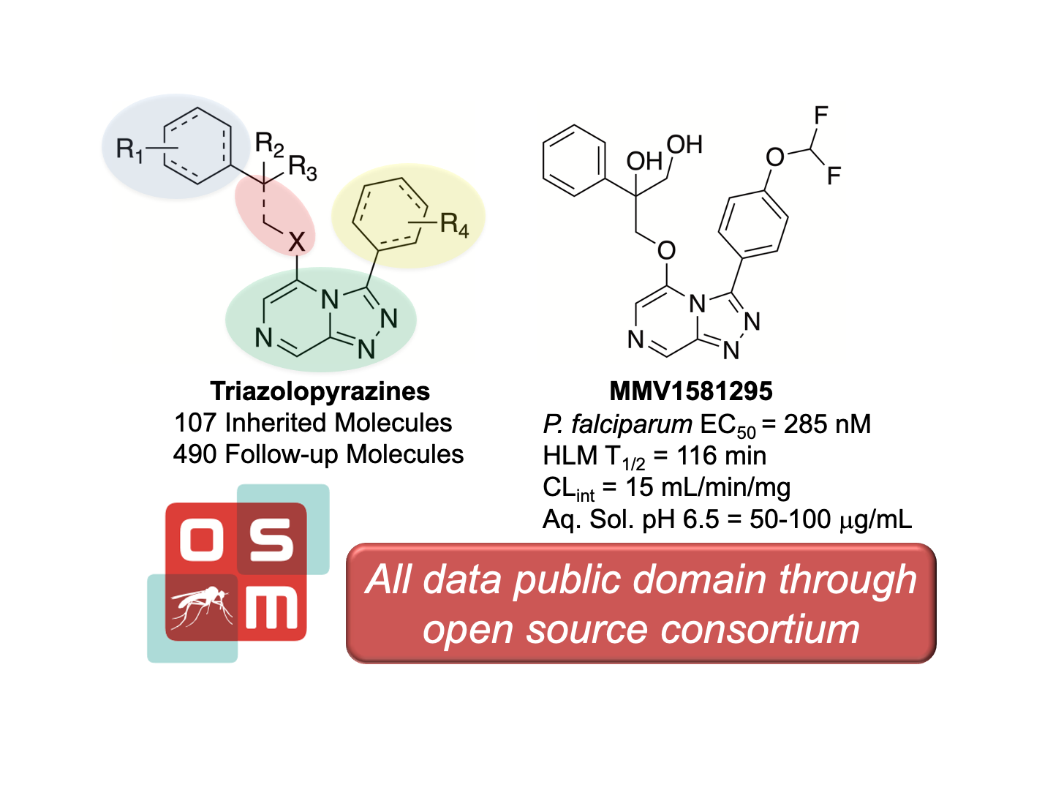

# Introduction

Malaria remains one of the top causes of human death annually, with 409,000 fatalities in 2019 out of an estimated 229 million cases. While the number of deaths due to malaria have decreased since the early 2000’s, when both political will and increased funding began to respond in earnest to the disease, increasing populations and other complicating factors have led to a leveling off of decreasing mortality rates. Reductions in malaria mortality and morbidity rates are forecasted to miss their 2020 goals even without taking into consideration the effects of the COVID-19 pandemic. [ <https://www.who.int/teams/global-malaria-programme/reports/world-malaria-report-2020> ISBN 978-92-4-001579-1] Contributing to the problem is a growing resistance of the parasite to antimalarial drugs, which includes the most recently developed artemisinin derivatives. [10.1056/NEJMoa1314981; 10.1016/j.pt.2017.01.004.] In order to counter the evolving drug resistance, new chemical matter is needed that possess novel mechanisms of action. [10.1186/s12936-019-2724-z.]

One approach to addressing the need for the development of novel antimalarial drugs was promulgated by the Medicines for Malaria Venture (MMV). Established in late 1999 and focusing on neglected tropical diseases, MMV created a public-private partnership model that filled the gap between drug discovery efforts in the pharmaceutical industry (return-on-investment driven paradigm) and drug discovery efforts of scientists working on molecular matter that fit a particular target candidate profile. [MMV Website - Our History. <https://www.mmv.org/about-us/what-we-do/our-history>. Accessed 14-DEC-2020.] As part of this model, MMV partnered with Pfizer in 2009 to undertake a high-throughput screen (HTS) of 160,000 compounds in Pfizer’s chemical library as potential starting points for new antimalarial drugs. [MMV Website - Press Release - <https://www.mmv.org/newsroom/press-releases/pfizer-and-mmv-advancing-international-research-efforts-fight-against>. Accessed 16-DEC-2020; Pfizer Website - Press Release - <https://www.pfizer.com/news/press-release/press-release-detail/pfizer_and_medicines_for_malaria_venture_advancing_international_research_efforts_in_the_fight_against_malaria>. Accessed 16-DEC-2020.] From the screening effort, of which the bulk of the results remain unpublished, a unique class of triazolopyrazines emerged as a promising new antimalarial series. Further development by MMV, first in collaboration with Pfizer, and subsequently with a contract research organization (TCG Lifesciences Pvt. Limited) resulted in multiple active compounds, examples of which are shown in **Figure 1A (SI File X Poster)**. While potent, **MMV669844** and **MMV670652** were found to be metabolized rapidly by human and mouse liver microsomes. **MMV639565** however, showed greater stability in the initial microsomal stability assays (HLM 16 μL/min/mg, RLM 70 μL/min/mg) and a promising in vivo PK profile (Rat (iv 0.5 mg/kg; po 3 mg/kg) Cl 44 mL/min/kg, Vss 0.9 L/kg, T1/2 0.6 h, Oral F 16%)) and was advanced to a mouse efficacy model in which it demonstrated rapid clearance of parasitemia in *P. falciparum* infection with an EC90 of 6.3 mg/kg (**Figure 1B**). In an independent study performed at Swiss TPH, at day 7 post-infection, n=2 mice treated with a 4 x 50 mg/kg *per os* dosing regimen of **MMV669844** were parasite-free (>99.9% activity) compared to n=4 untreated control mice (see SI) with a parasite detection limit of was 1 parasite in 10,000 erythrocytes (that is, 0.01%).

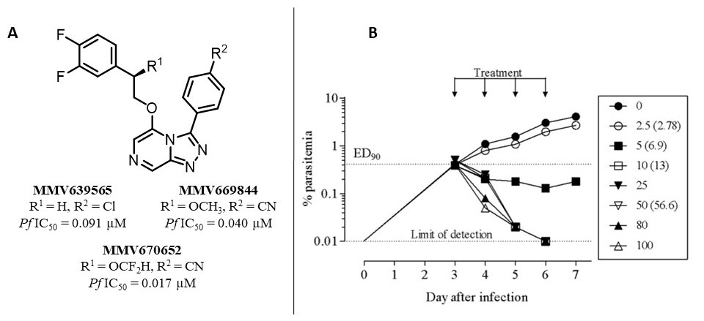

**Figure 1.** A) Example triazolopyrazines antimalarial hits from the MMV HTS of the Pfizer compound library. B) *In vivo* efficacy of **MMV639565**. Compound was administered orally, qd for four days at the doses indicated in the legend. Numbers in brackets represent dose (mg/kg) corrected according to quality control of formulation.

Following the initial screen of the Pfizer library, MMV provided a summary report that contained potency data on just over 100 compounds, along with some early pharmacokinetic and pharmacodynamic data on select compounds, to the Open Source Malaria (OSM) consortium. [MMV Website - <https://www.mmv.org/newsroom/news/potential-new-class-antimalarials-now-open-source>. Accessed 16-DEC-2020.] As part of the mission of the OSM, all information was made publicly available in order to jumpstart a lead optimization program aimed at improving the compounds’ solubility (≥100 μM), maintaining potency (<10 nM) and lowering the rates of metabolic clearance. The goal in making the project public was to solicit talent and expertise from a wide variety of sources and to investigate whether an open, unrestricted collaboration could progress the medicinal chemistry efforts during lead optimization in the way that had proven effective as a collaboration mechanism for a previous hit to lead project based on a small molecule derived from a screen by GlaxoSmithKline. [10.1021/acscentsci.6b00086] The participatory nature of OSM, in which anyone is free to contribute as the research is proceeding (rather than after it is completed), complements other initiatives centered on the deposition of open data for the research community. [10.1126/science.aat9446; Pathogen Box paper] The ultimate goal of the present project was to advance the compound development to a point that the chemical matter was attractive enough for funding towards further preclinical research since no “born open” compound (discovered, deposited and developed in the public domain) has ever progressed into a clinical trial. We present here 1) the combined results to date from the consortium’s work on this series for the treatment of blood stage malaria infections, 2) evidence of the relevant mechanism of action, and 3) suggested next steps.

# 

# **Results and Discussion**

## Synthesis

The Series 4 triazolopyrazines can, most broadly, be classified into two sub-classes of compounds: those with a heteroatom linker in the 5-position, and those with an amide linker (**Scheme 1**). The synthesis of the former may be achieved by initial displacement of a chlorine atom from 2,6-dichloropyrazine with hydrazine hydrate to give the hydrazine intermediate (**Scheme 1 - Route A**). Condensation with the appropriate aldehyde and subsequent oxidative cyclization using (diacetoxyiodo)benzene affords the cyclized triazolopyrazine core. Final products were obtained upon displacement of the 5-position chlorine atom with an appropriate nucleophile (either synthesised or commercially available). In the case of the amide-linked compounds, the linker was first installed *via* T3P mediated amide coupling with 6-chloropyrazine-2-carboxylic acid and the appropriate amine (**Scheme 1 - Route B**). The subsequent steps to form the triazolopyrazine core were performed in the same manner as for the heteroatom-linked compounds. In both cases, the synthetic procedures used were robust and applicable to multi-gram scale. The synthetic protocols for any compound in this paper may be found in full in the supplemental information, which also provides links to the complete synthetic details of each experiment within the publicly available electronic laboratory notebooks (ELNs). A focused subset of Series 4 compounds containing phenyl isosteres has been published elsewhere, [10.1021/acs.jmedchem.0c00746] as have examples of a tele-substitution reaction we discovered during the course of this project in which nucleophilic addition in the final step of the synthesis of the heteroatom series was found to take place at the 8-position (**Scheme 1 - Route B**). [10.1021/acs.joc.0c01045]

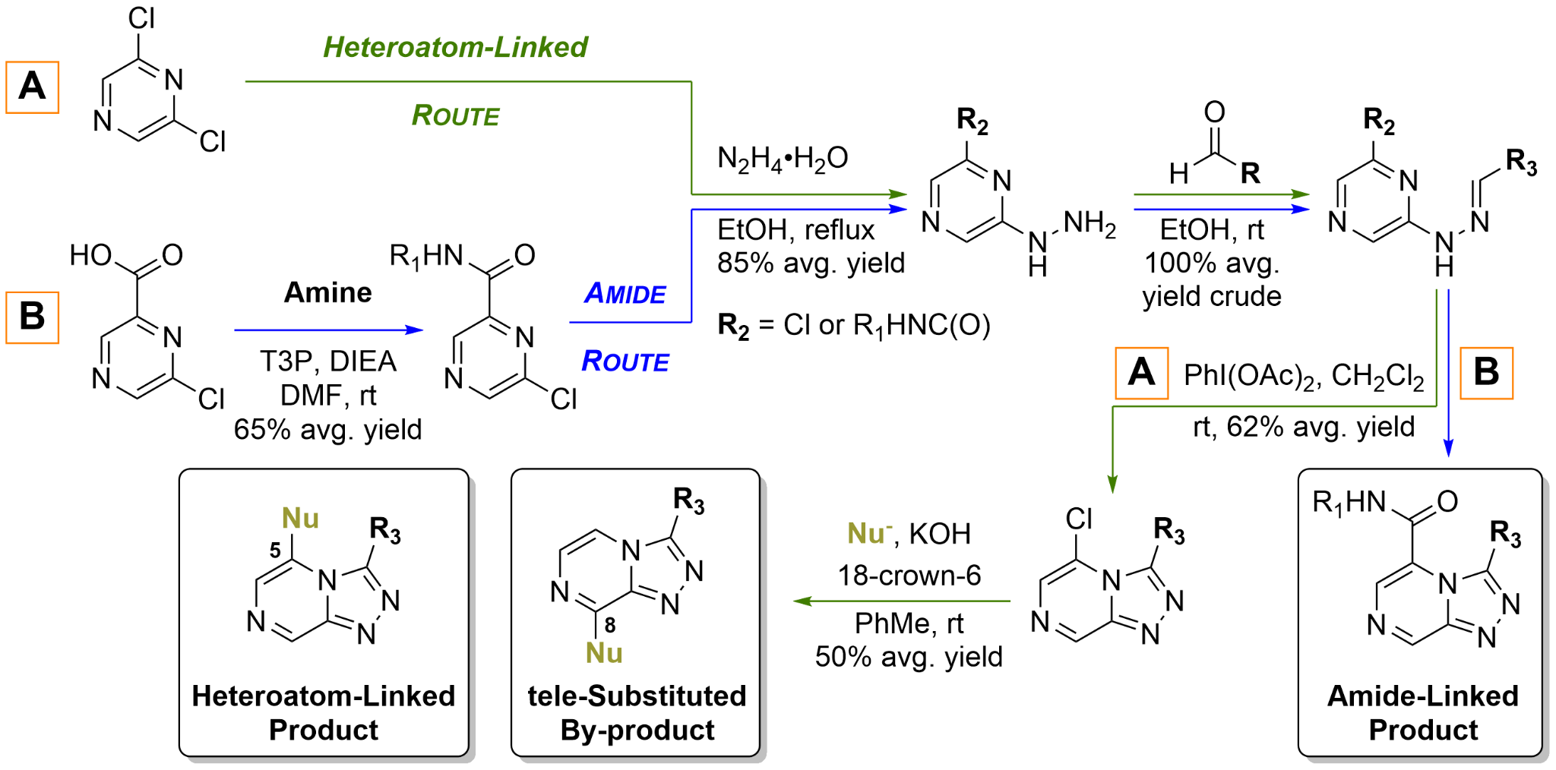

**Scheme 1.** General synthetic route to either the 5-substituted heteroatom-linked (**Route A**, Nu- = RO-, RNH-, RS-) and/or amide-linked (**Route B**) triazolopyrazines.

## Structure-Activity Relationships

As a result of this open source project having many contributors worldwide, varying sources of *in vitro* assays were used which evaluated the compounds against either the NF54 or 3D7 strain of *P. falciparum*; suitable controls were used throughout to ensure data between assays (*e.g.*, inherited *vs.* generated data) could be compared. Both strains are comparable, with the differences in that the NF54 strain is sensitive to all known drugs, while 3D7 strain is a clone of the NF54 strain and is known to produce fewer gametocytes in the *in vitro* cultures. [10.1038/nprot.2016.096] The activities being reported in this communication represent an averaged value of activity. A complete listing of compound activity against individual *Plasmodium* strains is provided in the supplementary materials. Any cLogP values reported were calculated using DataWarrior. [Openmolecules.org Website - DataWarrior: <http://www.openmolecules.org/datawarrior/>. Accessed 18-DEC-2020.] The following sections present a summarized overview of the key SAR findings. A complete table of analogs tested in the project is contained in the supplemental information and is maintained live on the OSM compound Master List. [link] The open source nature of the project led to various contributions arising from the community, ranging from suggestions of chemical space to explore (e.g. *N*-linked compounds shown in Figure 5) through to fully-fledged synthesis and evaluation of analogs in contributor laboratories (e.g. reversed amide shown in Figure 3).

The importance of maintaining the triazolopyrazine scaffold was established early in the program through exploration of variations in the heterocyclic core and also some limited chain transpositions (**Figure 2**). A modest loss in potency was observed upon the systematic replacement of the core triazole nitrogens with –CH groups (**MMV669846** and **MMV670250**) as compared to the triazolopyrazine **MMV639565**. The imidazopyrazole analog **MMV669846** was not pursued further due to its high similarity to a class of antimalarial imidazopyrazoles already reported by Novartis and which possessed a different mechanism of action. [10.1021/ml500244m] While not a core modification, any substitution at the 8-position (e.g., **MMV669541**) also led to a significant loss in activity. [10.1021/acs.joc.0c01045] Oxidation of the pyrazine nitrogen to the *N*-oxide **MMV668962** or the pyrazine ring itself to the triaziolopyrazin-8-one **MMV669025** also resulted in loss of activity. Transposition of the ether side chain from the 5-position to the 6-position (**MMV670945**) was well tolerated and even resulted in a boost in activity. Variation of this analog **MMV670945** was not pursued further due to synthetic throughput limitations, but it is recognized that this may be an opportunity for a future route of optimization. Transposition of the pyrazine nitrogen of **MMV670945** to give the triazolopyridazine **MMV672939** led to a large reduction in potency. Both of the 6-position ether analogs distantly resembled several series of antimalarial imidazopyridazines and pyrazolopyridines reported in the literature and which are likely to have a different mechanism of action. [10.1021/acs.jmedchem.5b01605; 10.1021/jm500098s.] It was decided that further exploration in the variation of the pendant groups at the 3- and 5-positions of the triazolopyrazine core would provide the most fruitful compounds.

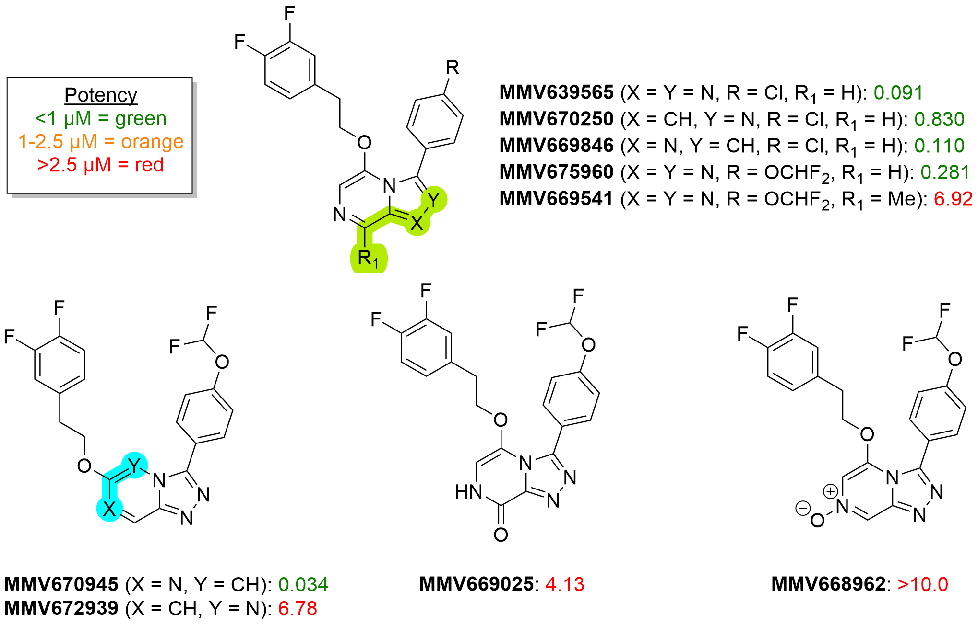

**Figure 2.** Activity profile resulting from modifications to the triazolopyrazine core of the Series 4 scaffold.

The identity and length of the linker unit between the 5-position aryl group and the triazolopyrazine core proved influential on activity (**Figure 3**). An ether linker with two methylene units between it and the pendant phenyl ring (**MMV897698**) was ideal, with longer or shorter chain lengths resulting in reduced activity. [10.1021/acs.jmedchem.0c00746] A significant loss in potency was seen upon replacement of the ether linker with a thioether (**MMV1581336**), sulfone (**MMV693163**), sulfoxide (**MMV693166**), or amine (**MMV1634424**) linker. Interestingly, exchanging the heteroatom with a methylene group (**MMV669304**) was well tolerated and maintained activity; however, this change was accompanied by an increase in cLogP and so its further exploration was deprioritized.

The corresponding amide series showed activities comparable to the ether series. Aniline-derived amides with *meta-*substitution (**MMV669542**) showed superior activity over compounds containing substitution at the *ortho*- or *para*- positions (see Supplemental Information). In an effort to avoid the inclusion of a potentially undesirable aniline moiety, a related trifluoromethyl-pyridyl derivative (**MMV670944**) was synthesized and found to be nearly equipotent. All other unsubstituted pyridyl analogs however, were found to be inactive (see Supplemental Information). Benzylamine-derived amides were also synthesized and again followed a similar activity profile to the aniline amides with the *ortho-*substitution being favored (**MMV668958**). Methylation of the amide nitrogen (**MMV669105**) caused a ~4-fold loss in potency. The reverse amide **OSM-W-6** was also found to be inactive. A variety of other aliphatic amides were assessed but none were discovered to have sub-micromolar potency against *P. falciparum*. While select amide compounds did show promising activity and further exploration of the SAR was warranted, early exploration of hERG binding suggested the amide linker introduced a liability (see **Table 1**). The amide-linked **MMV670944** was found to possess a pIC50 of 5.60, [10.1016/j.vascn.2006.02.003] and upon further investigation, a number of additional amide-linked compounds were also found to provide higher levels of hERG binding than the ether-linked compounds. As a result, the amide sub-series was deprioritized.

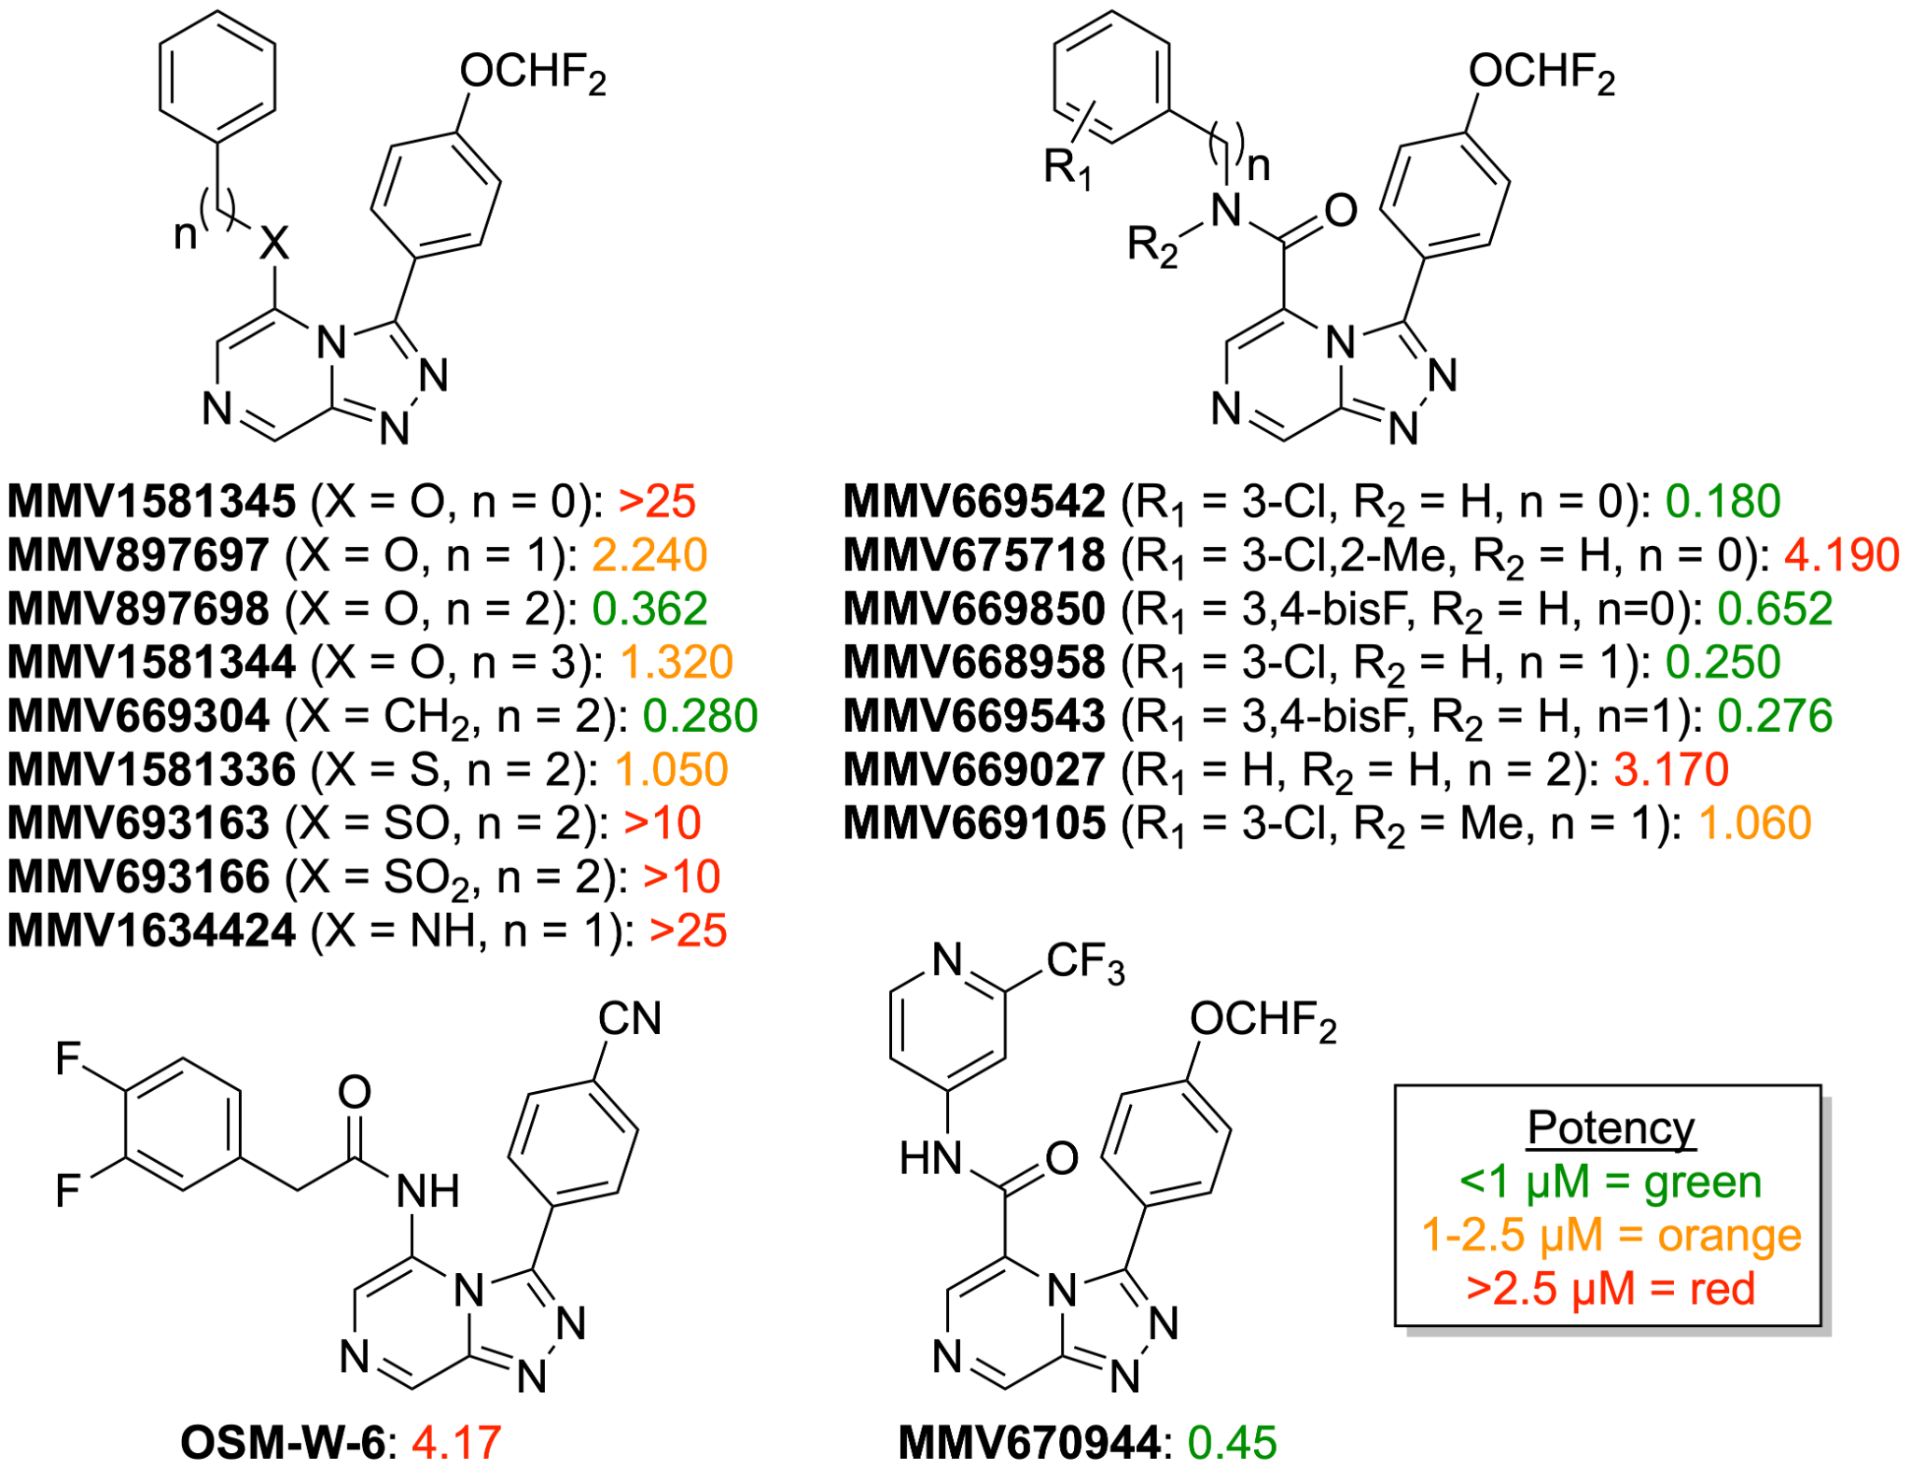

**Figure 3.** Survey of modifications to the linker region between the pyrazolopyrazine core and the northwest pendant functionality.

As a general trend (**Figure 4**) throughout the series as a whole, replacement of the northwest pendant phenyl ring with a 3,4-difluorophenyl substitution pattern (**MMV639565** and  **MMV675960**) resulted in increased activity compared to the unsubstituted (**MMV663915** and **MMV897698** respectively) or monosubstituted (**OSM-W-10**) analogs. *Meta*-substitution alone was well tolerated as seen with the methoxy analog (**MMV897711**), while *para*-substitution was much less favourable with this functional group (**MMV897712**). While thiophene **MMV1634428** did demonstrate modest activity, an extensive search of other heteroaromatic replacements for the northwest phenyl ring was not undertaken and may represent a future area of exploration. As part of a separate investigation, compounds in which the pendant phenyl ring was replaced with saturated heterocycles and hydrocarbon cages were made in an attempt to improve solubility and metabolic stability *via* deplanarization and dearomatization. Such changes generally resulted in reduced efficacy, with a small number of notable exceptions (for example the cubane derivative **MMV897700** and the carborane **MMV1576784** shown in Table 1). [10.1021/acs.jmedchem.0c00746]

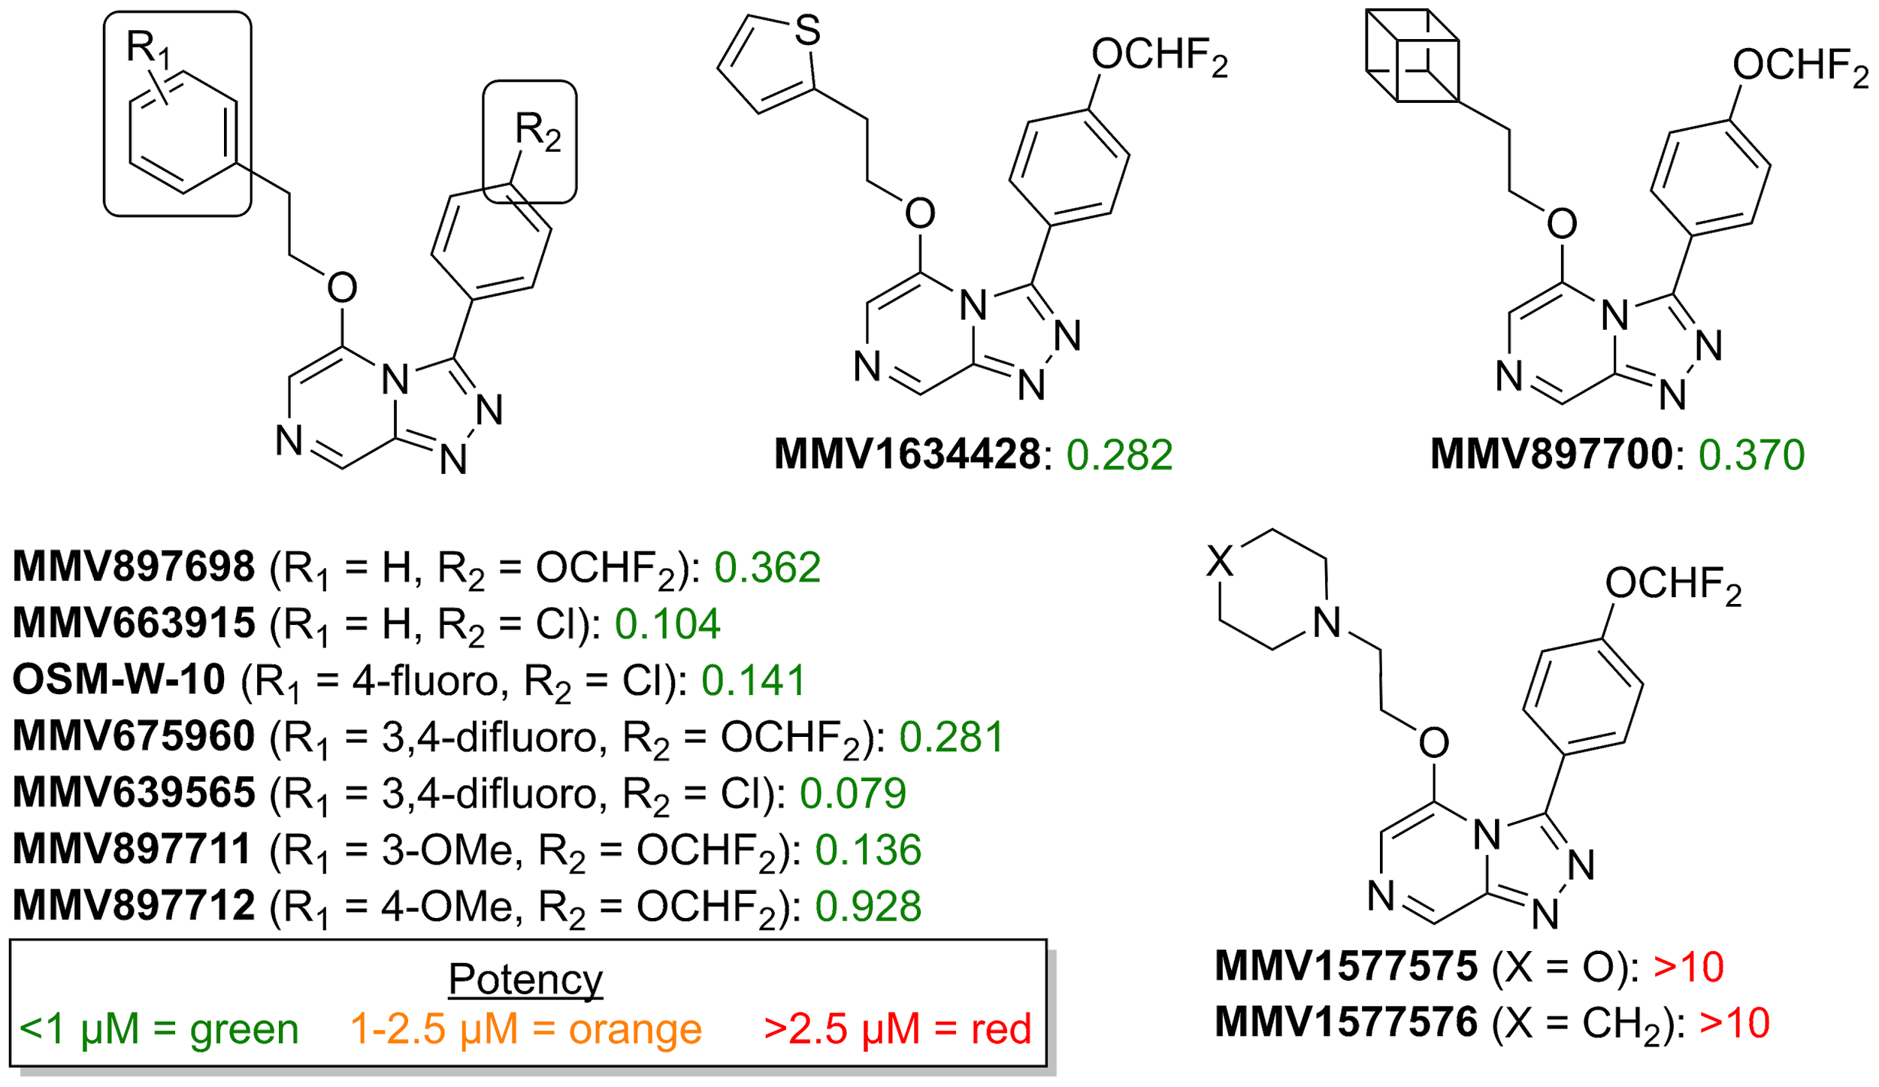

**Figure 4.** Survey of modifications to the northwest region of the scaffold linked to the pyrazolopyrazine core *via* a ethylene-ether linkage.

The triazole 3-position substituent (northeast pendant phenyl - **Figure 5**) was found to be highly sensitive to substitution. Generally, alkyl, cyano, nitro, or halogenated substituents at the *para-* position (**MMV675960**, **MMV639565**, **OSM-W-9**, **MMV1580435**, **MMV1581334**) resulted in analogs which retained sub-micromolar potency. Carboxylic acids (**MMV1580437**, **MMV1580436**), amides (**MMV1576794**, **MMV1576793**) and sulfonamides (**MMV1577569**) significantly reduced activity or rendered the compounds inactive. A primary aniline at the *meta-* position (**MMV1580434**) gave weak activity which was improved by the addition of a halogen at the *para-* position (**MMV1580433** and **MMV1581334**). The chloro-aniline **MMV1580433** was one of the most potent compounds of this series; however, acetylation or methylation of the amine caused a loss of activity (see SI). Limited attempts to find a bioisosteric replacement for the aniline generally resulted in compounds that were less active (**MMV1579431**, **MMV1580431** and additional analogs detailed in the Supporting Information). While the chloro-aniline **MMV1580433** was intriguing, due to the lack of additional metabolic safety data, it was deprioritized out of potential concerns that the aniline would be a liability. [<https://doi.org/10.1021/tx200168d> ; <https://doi.org/10.2174/0929867321666141112122118> ; <https://dx.doi.org/10.1021/acsmedchemlett.9b00687>] Further investigation into the SAR around **MMV1580433** seems to be warranted however, especially if it can be established the the chloro-aniline does not lead to a reactive metabolite or if modifications can be made to mitigate the possibility. [<https://doi.org/10.1021/acs.jmedchem.1c00514> ]

As mentioned earlier in the discussion of the modification to the triazolopyrazine core, despite evidence that on related scaffolds that a *para*-methylsulfone substituent on the phenyl ring would result in highly potent compounds, analog **OSM-W-5** was found to be inactive in this series. [10.1021/acs.jmedchem.5b01605; 10.1021/jm500098s] In further SAR exploration, and in keeping with the goal of improving metabolic clearance and solubility, saturated and unsaturated heterocycles were also assayed as possible replacements to the substituted northeast phenyl ring. Although these compounds usually resulted in lower clogP values, they were generally either less active or inactive (**Figure 5**).

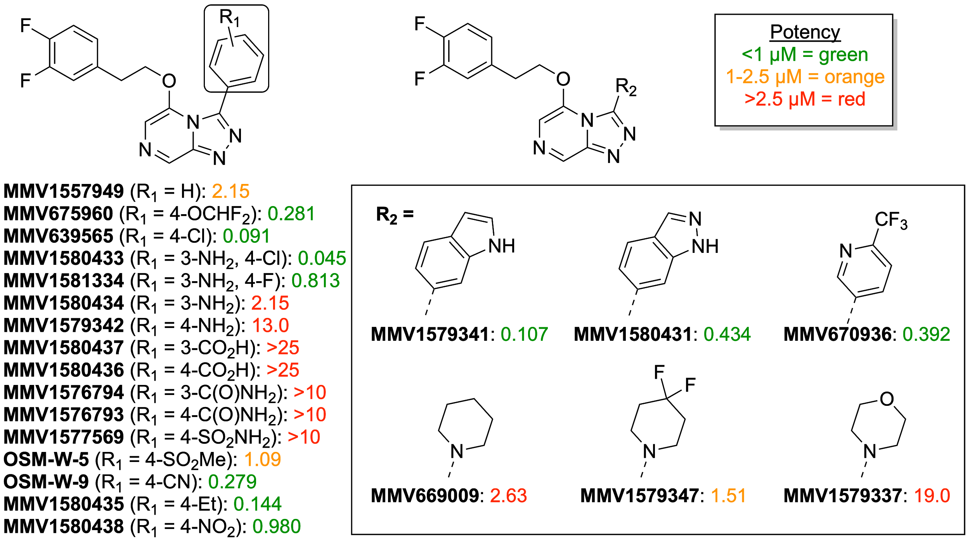

**Figure 5.** Survey of modifications to the northeast region of the series linked to the triazolopyrazine core at the 3-position.

Finally, benzylic-substituted analogues were designed to mitigate a potential metabolic liability at this position and improve solubility. These modifications were generally beneficial, with many compounds showing sub-micromolar activity. The most notable compounds containing benzylic substitutions are the alcohol- (**MMV672687**, **MMV672723**, **MMV1794637, MMV1581298**, **MMV688896**, **MMV693155**, and **MMV1580315/1581295**), fluoro- (**MMV672936** and **MMV672727**) and dimethylamine-containing (**MMV897763**) analogs, all of which showed improved activity over the compounds with the unsubstituted ethylene linker (**Figure 6**).

Additionally, the installation of alcoholic functionality translated to improved clogP values, and this modification was pursued further. The benzylic position in the phenethyl side-chain was found to be prone to metabolic oxidation (see next section on Metabolism and Solubility), so several compounds having di-substitution at this position were made (**Figure 6**). Disappointingly, di-substitution tended to lower the potency over mono-substitution. Of particular note are the two diols **MMV1581298** and **MMV1581295**, which showed reduced potency as compared to their singly hydroxylated counterparts **MMV672687 / MMV670947** and **MMV688896 / MMV693155** respectively. Furthermore, diol **MMV1581295** was first identified as a major metabolite from a biosynthetic metabolism experiment and was initially reported to have an IC50 against *P. falciparum* of 9 nM. Upon resynthesis, **MMV1581295** was instead found to be much less potent with a mean potency of 285 nM (**Figure 7**). It is unknown if a single enantiomer was formed during the biosynthetic assay and this discrepancy in activity will need to be further explored. Methyl substitution at the benzyl position was tolerated and allowed potency to be maintained (**MMV672723**, **MMV672727** and **MMV1634429**). Also of note, modifications that were clearly detrimental to potency were the installation of a carboxylic acid (**MMV1579336**) at the benzyl position, oxidation of the benzyl position to the ketone (**MMV1557932** and **MMV1557940**), or bis-hydroxymethylene substitution **MMV1634435**. Ultimately, while synthetically challenging, the benzylic position has been identified as a site that can potentially be leveraged to provide compounds that offer a balance between potency, solubility and metabolic stability. Efforts to further modify the benzylic position are discussed later in the manuscript under future directions.

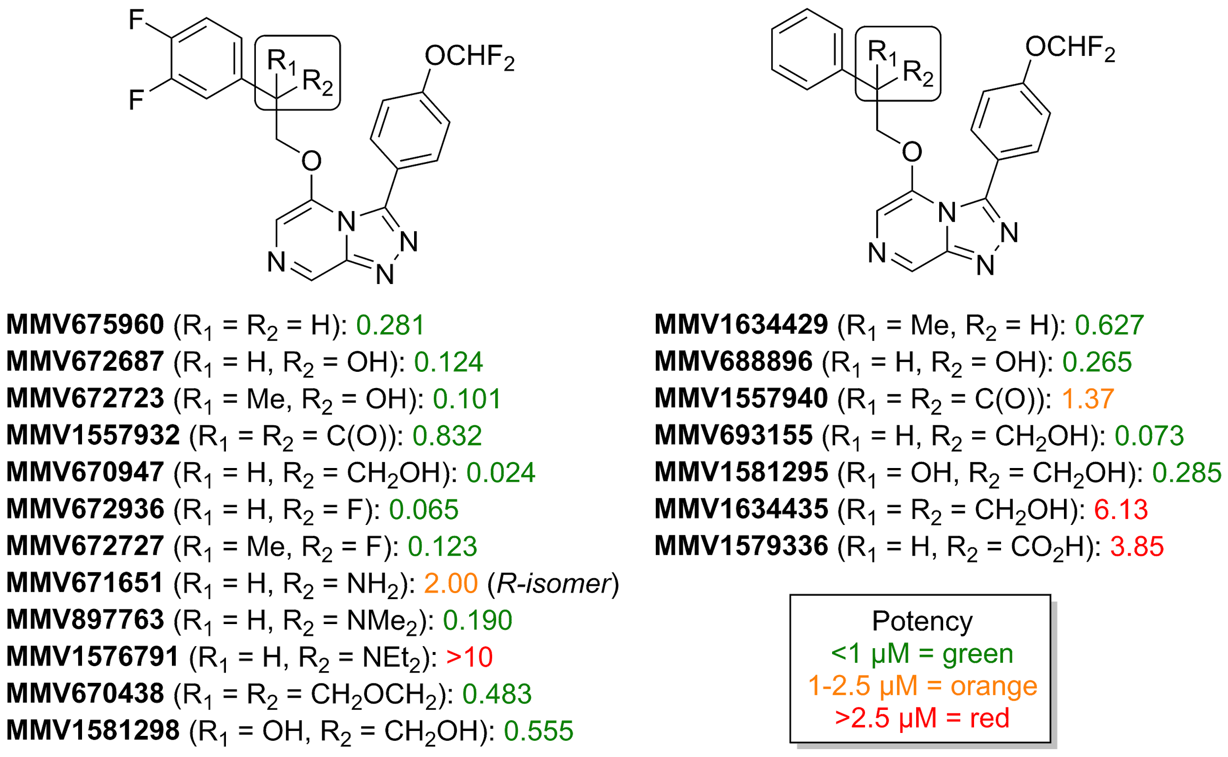

**Figure 6.** Survey of modifications to the benzylic position of the ether-linked analogs.

In summary, a number of key motifs are required to maintain activity. The triazolopyrazine core is essential for activity with any modification resulting in a loss against *P. falciparum*. A pendant aromatic ring at the 5-position of the core is required for activity, with the 3,4-difluoro being the preferred substitution pattern. *Para*-substituted aromatic rings were most beneficial for activity at the 3-position. The linker tolerated a number of modifications, with primary alcohols at the benzylic position providing an improvement in both potency and clogP.

## *Metabolism*, S*olubility and Safety*

A number of key compounds from the SAR investigations were evaluated for their metabolic and physicochemical properties, along with hERG activity and cytotoxicity (**Table 1**). None of the compounds tested showed significant hERG activity (a safety margin of 30-fold between hERG and *P. falciparum* IC50 was deemed safe *in vitro*) and cytotoxicity was found to generally be low (**Table SX**). Many of these compounds showed improved clearance and solubility over one of the initial Series 4 compounds **MMV897698**, showing that it is potentially possible to meet the MMV PK/PD progression criteria in this series. [Website MMV Target Product Profiles & Target Candidate Profiles. https://www.mmv.org/research-development/information-scientists/target-product-profiles-target-candidate-profiles. Accessed 22-DEC-2020.] In particular, the carboxylic acid **MMV1579336** displayed much reduced clearance and longer half-life, but was inactive against *P. falciparum*. As indicated in the previous discussion of the SAR of the benzylic position, compounds containing a benzylic alcohol (**MMV688896**, **MMV672687**, and **MMV693155**) are promising not only due to their potency, but their early pharmacokinetic profile. The majority of compounds had modest solubility (12 - 50 ug/mL) but increasing the lipophilicity of the ether substituent **MMV897700** and **MMV1576784** had a significant negative impact on solubility.

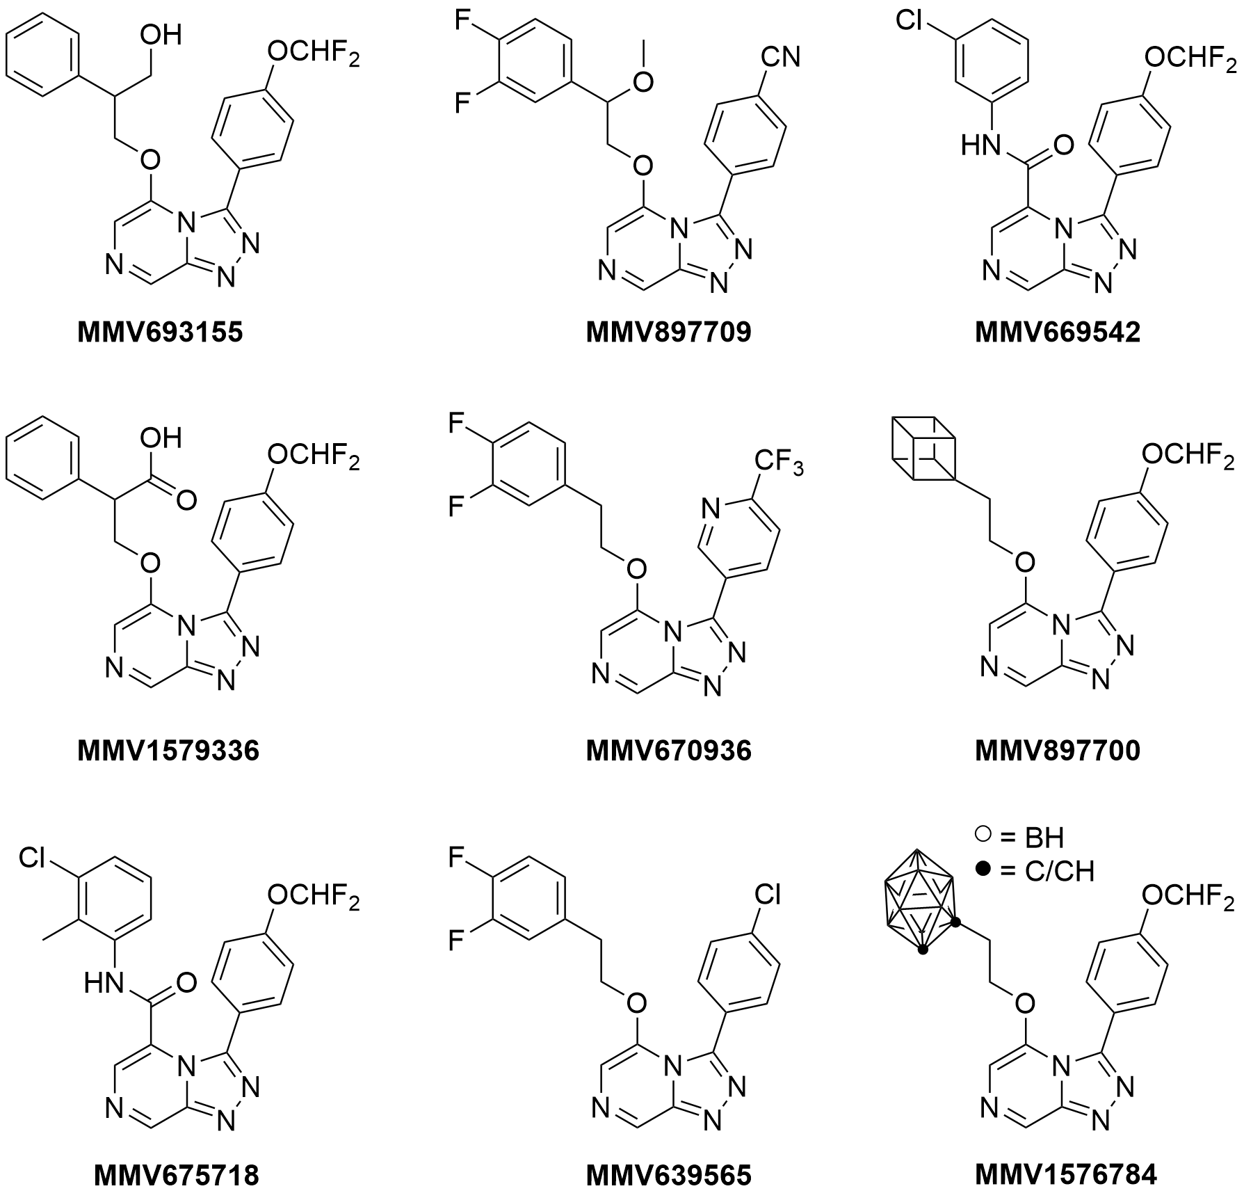

|  |  |  |  |  |  |  |  |
| --- | --- | --- | --- | --- | --- | --- | --- |
| ***Compound*** | ***P. falciparum EC50 (uM)*** | ***CLint (uL/min/mg)*** | | ***T1/2 (min)*** | | ***Solubility pH 6.5 (ug/mL)*** | ***hERG***  ***pIC50 (uM)*** |
| ***HLM*** | ***Rodent LM*** | ***HLM*** | ***Rodent LM*** |
| **MMV693155** | 0.104 | 49 | 361a | 35 | 5a | 12.5 - 25 | 4.7 |
| **MMV897709\*** | 0.150 | 47 | 159a | 37 | 11a | 12.5 - 25 | 5.2 |
| **MMV669542** | 0.211 | 72 | 290b | 13.6 | 6b | <2.5 (pH 7.4) | 4.9 |
| **MMV675718** | 4.190 | 114 | 166a | 15 | 10a | 12.5 - 25 | 5.1 |
| **MMV1579336** | 3.880 | 7 | 7a | 255 | 255a | 25 - 50 | 5.0 |
| **MMV670936** | 0.392 | 71 | 132a | 24 | 13a | 3.1 - 6.3 | 4.5 |
| **MMV897700** | 0.372 | 197 | 573a | 9 | 3a | <1.6 | 5.4 |
| **MMV1576784** | 0.050 | 249 | 866a | 7 | 2a | <1.6 | 5.4 |
| **MMV639565** | 0.091 | 33 | 193a | 53 | 9a | 3.1-6.3 | *nd* |

**Table 1**. Clearance, solubility and hERG data for selected analogs. aMouse liver microsomes. bRat liver microsomes. *nd* = Not determined.. *Compound **MMV670709** was the racemic variant of the inherited compound **MMV689844**.

A survey of compounds were investigated as candidates for late-stage biofunctionalization using liver microsomes (**Fig. 7**). The compounds were incubated with human liver microsomes along with a standard at known concentration. Following the incubation period, the metabolites were isolated *via* HPLC and then characterized by NMR analysis. The isolated metabolites were then assayed against *P. falciparum*to determine their antimalarial activity. [10.1124/dmd.114.059204] The metabolites generated from the representative amide compounds (**MMV670246** and **MMV670944)** were found to be oxidized on the nitrogen heterocycles, both of which led to reduced efficacy *in vitro*. Metabolism of the compound possessing a benzylic methoxy group (**MMV897709**) led to the observation of the benzyl alcohol metabolite and then ultimately the less desirable benzylic ketone product. As described previously, the metabolite resulting from oxidation of compound **MMV693155** was initially ascribed the identifier **MMV1580315**. The identified metabolite was immediately assayed and found to possess increased potency as compared to the parent compound. Compound **MMV1580315** was first thought to have been oxidized on the Northwest pendant phenyl ring to give a phenolic product. The promising activity of metabolite **MMV1580315** rapidly initiated the compound's independent synthesis for retesting. It was immediately apparent following synthesis of the phenol analog of **MMV897709** that it did not match the metabolite **MMV1580315**. The NMR data for the metabolite was re-analyzed and the correct structure determination of the product resulting from benzylic oxidation was determined. The structure was then confirmed following independent synthesis and redesignated **MMV1581295**. While the structure of the metabolite was confirmed absolutely, the discrepancy between the initial activity during the biofunctionalization assay and subsequent re-testing has not been resolved. As mentioned previously in the section on the SAR of the benzylic position, it is believed that optimization of the substitution on this portion of the linker may be the key to compounds that balance potency and metabolic stability. Using the knowledge gained from the SAR and metabolic studies, future work in this area is outlined later in the discussion section of the manuscript.

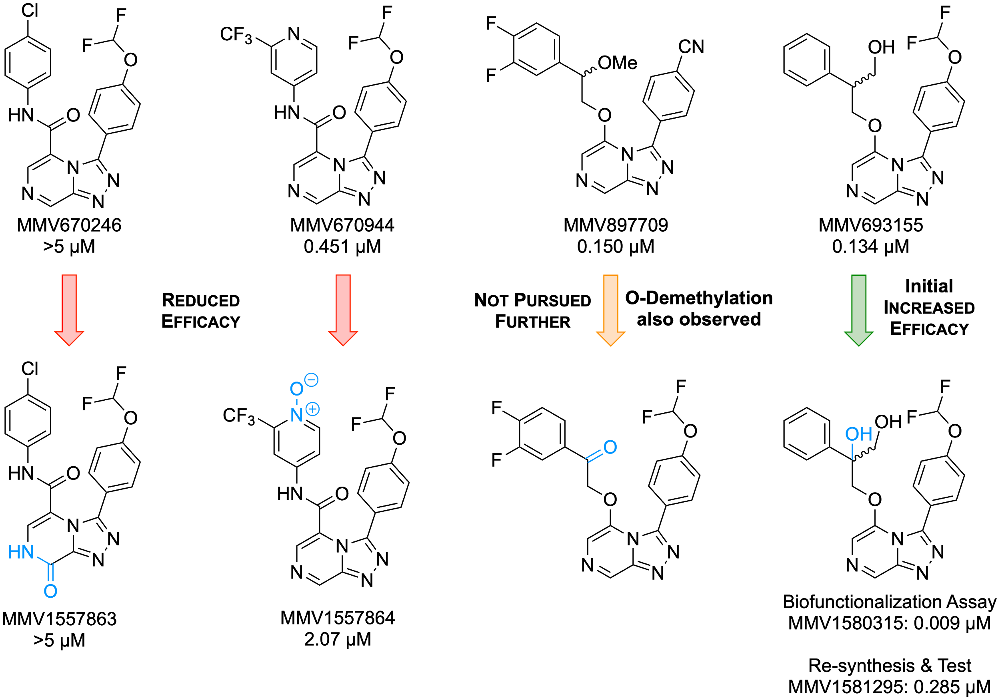

**Figure 7.** Compounds of interest and isolated metabolites, with major structural changes highlighted in blue.

In addition to the above, it was also noted that oxidation of the triazolopyrazine core was consistently observed in addition to side chain-specific transformations such as *O*-dealkylation of ethers or benzylic oxidation. In a further effort to understand how the triazolopyrazines were being metabolized, an effort was dedicated to determining whether this oxidation was due to traditional CYP enzymes or whether aldehyde oxidases (AOs) were involved. To investigate this, a comparison of the half life of select Series 4 compounds was studied in human liver cytosol versus that of known AO substrates. From this work, it was observed that compounds containing benzylic alcohols, such as **MMV688896** or **MMV693155**, were relatively stable to AO metabolism, while amides were metabolised rapidly. Based on these studies and combined with the hERG data (**Table 1**), the amide side chains were deprioritized despite initially promising clearance and solubility.

## Mechanism of Action

Preliminary investigation of the mechanism of action of Series 4 compounds points to the *Plasmodium falciparum* P-type ATPase 4 (*Pf*ATP4) as the target. Several studies have demonstrated that *Pf*ATP4 is a sodium efflux transporter that is required to maintain sodium homeostasis in the malaria parasite, and that inhibition of this protein results in an accumulation of sodium ions which leads to parasite death. [10.1016/j.chom.2012.12.006.; 10.1016/j.ijpddr.2015.07.001, 10.1038/s41598-019-46500-5] A panel of Series 4 triazolopyrazines were screened in a fluorescence-based assay against mature *P. falciparum* 3D7 trophozoites to measure any increases in intracellular Na+ and H+ concentrations. The known *Pf*ATP4 inhibitor, cipargamin, was used as the positive control and helped classify the *Pf*ATP4 inhibition ability of a compound as *Yes*, *Moderate* or *No* (**Table SX, Figure SX**). A strong correlation was observed consistent with the more potent inhibitors showing greater increase in sodium ion concentration and elevations of the pH levels (**Figure 8**).

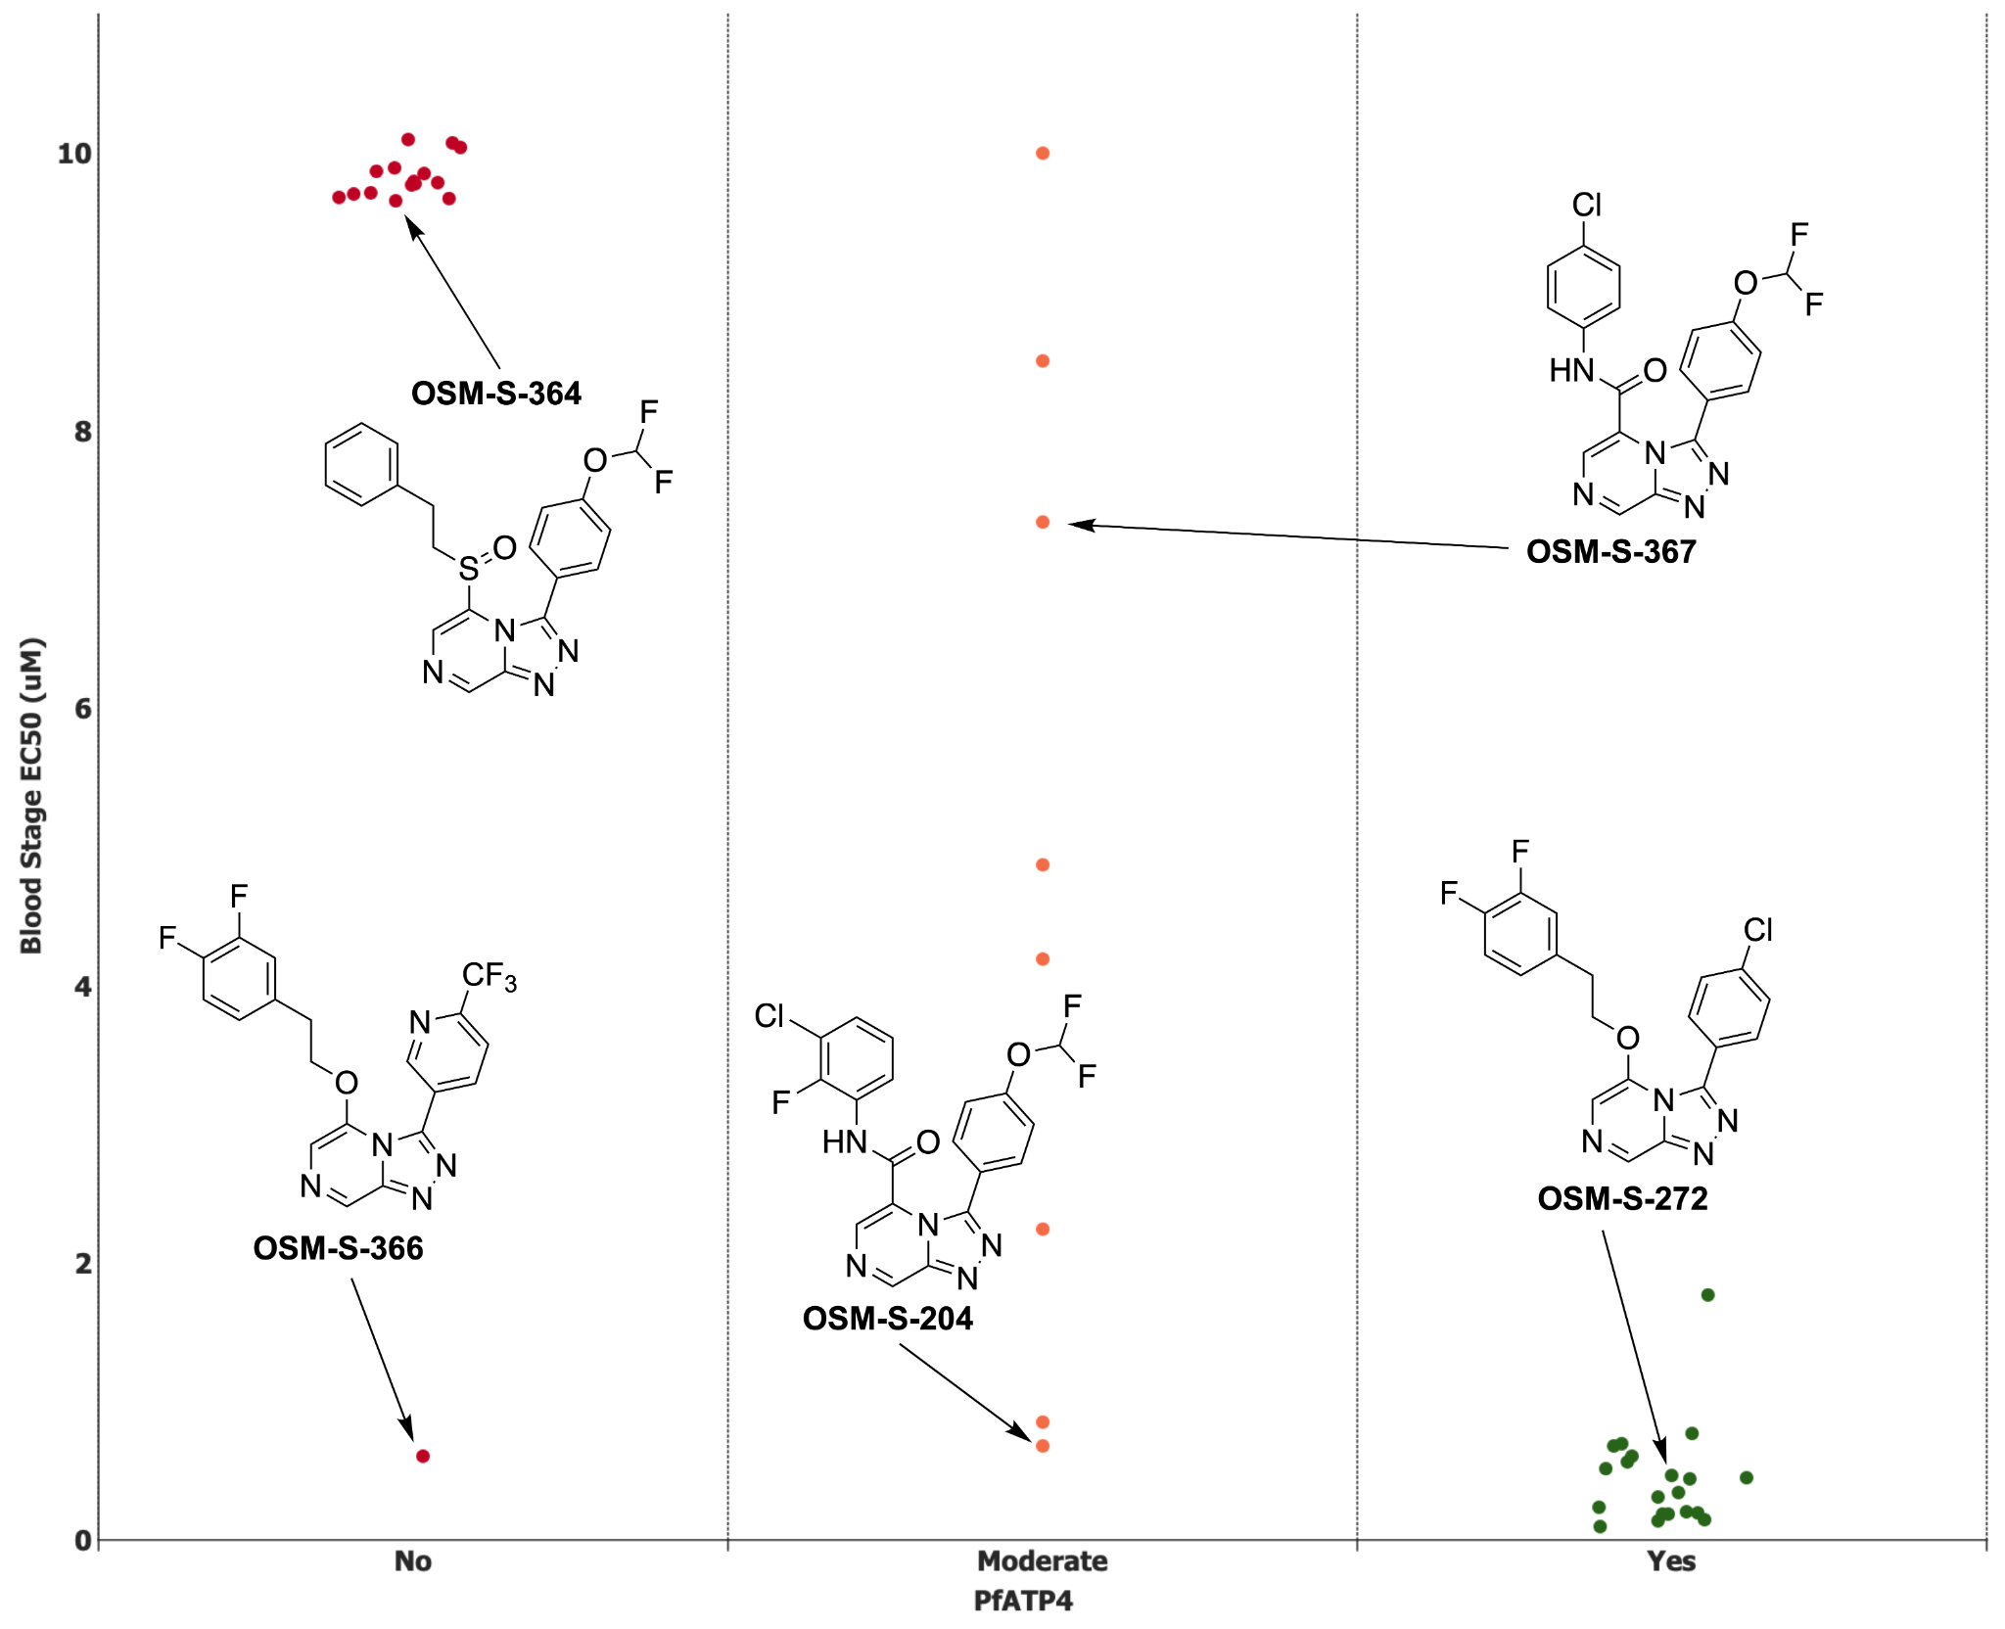

**Figure 8.** Correspondence of activity against *P. falciparum* versus *Pf*ATP4. ***Yes***: gives rise to an increase in [Na+]cyt and pHcyt that is similar in magnitude to that of 50 nM cipargamin when tested at 1 µM. ***Moderate***: gives rise to an increase in [Na+]cyt and pHcyt when tested at 1 µM and/or 5 µM, with its effect at 1 µM being lower in magnitude than that of 50 nM cipargamin. ***No***: does not affect [Na+]cyt or pHcyt when tested at 1 µM or 5 µM.

A number of different chemotypes have been implicated as inhibitors of *Pf*ATP4 as the target for their mechanism of action. [10.1111/mmi.12765; 10.1038/s41598-018-26819-1] Additionally, induced resistance studies for several of the Series 4 compounds, activity in an *in vitro* assay for the *Pf*ATP4 target, correlated with blood stage antiparasitic activity with cross resistance being observed with known *Pf*ATP4-resistant mutants (**Figure SX**). [10.1074/jbc.RA118.003640]

The mode of action was further investigated using an established, unbiased metabolomics approach for studying antimalarials. [DOI: 10.1128/AAC.01226-16.] The active compound **OSM-S-218** (MMV669844, *P. fal* EC50 = 0.04 µM), and the inactive analogue **OSM-S-291** (MMV689968**,** *P. fal* EC50 >5 µM) were used under sublethal conditions against trophozoite stage *P. falciparum* parasites to induce specific metabolic perturbations, alongside known antimalarial reference compounds atovaquone (**ATV**), chloroquine (**CQ**), and dihydroartemisinin (**DHA**); and three antiplasmodium compounds thought to be *Pf*ATP4 inhibitors (**Figure SX**). Metabolomics analysis of cell pellets and spent media allowed reproducible coverage of a range of metabolic pathways, with the most significant **OSM-S-218**-induced perturbations observed within peptide, lipid and energy metabolism (**Figure SX**). A multivariate sparse-PLSDA analysis of cell pellet samples revealed that the primary metabolic impact of **OSM-S-218** treatment was consistent with the perturbations observed for the three reference *Pf*ATP4 inhibitors, and these samples clustered distinctly from the other reference compounds with different mechanisms of action (**Fig. 9A** and **Fig SX**). Cultures incubated with the inactive analogue (**MMV689968**) clustered with the untreated controls, confirming the lack of impact on parasite biology.

The metabolite features responsible for the distribution of samples across the first sPLSDA component were primarily peptides derived from haemoglobin digestion, which were depleted following treatment with the *Pf*ATP4 inhibitors, DHA, and to a lesser extent, chloroquine (**Figure 9B**). These results are consistent with previous data, and suggest that inhibition of digestive vacuole function is the major impact of each of these classes of antimalarials. [DOI: 10.1128/AAC.01226-16.] Differentiation between *Pf*ATP4 inhibitors (including **OSM-S-218**) and the known digestive vacuole-targeting drugs (chloroquine and DHA) was observed in the second sPLSDA component, which included three lysophosphatidylserines (lysoPS) in the top five metabolites contributing to this component (**Figure 9C**). Increased levels of lysoPS were observed in cultures treated with *Pf*ATP4 inhibitors (including OSM-S-313), whereas levels of these lipids were generally depleted following treatment with the digestive vacuole-targeting drugs Previous studies of *Pf*ATP4 inhibitor **(+)-SJ733** revealed enhanced PS exposure in the outer membrane leaflet of infected erythrocytes. [DOI: 10.1073/pnas.1414221111] As PS exposure is a marker of eryptosis, a cell death mechanism associated with increased activity of phospholipase A2, the enzyme responsible for lysoPS production, it is likely that the observed perturbation to PS metabolism is associated with the induction of eryptosis.

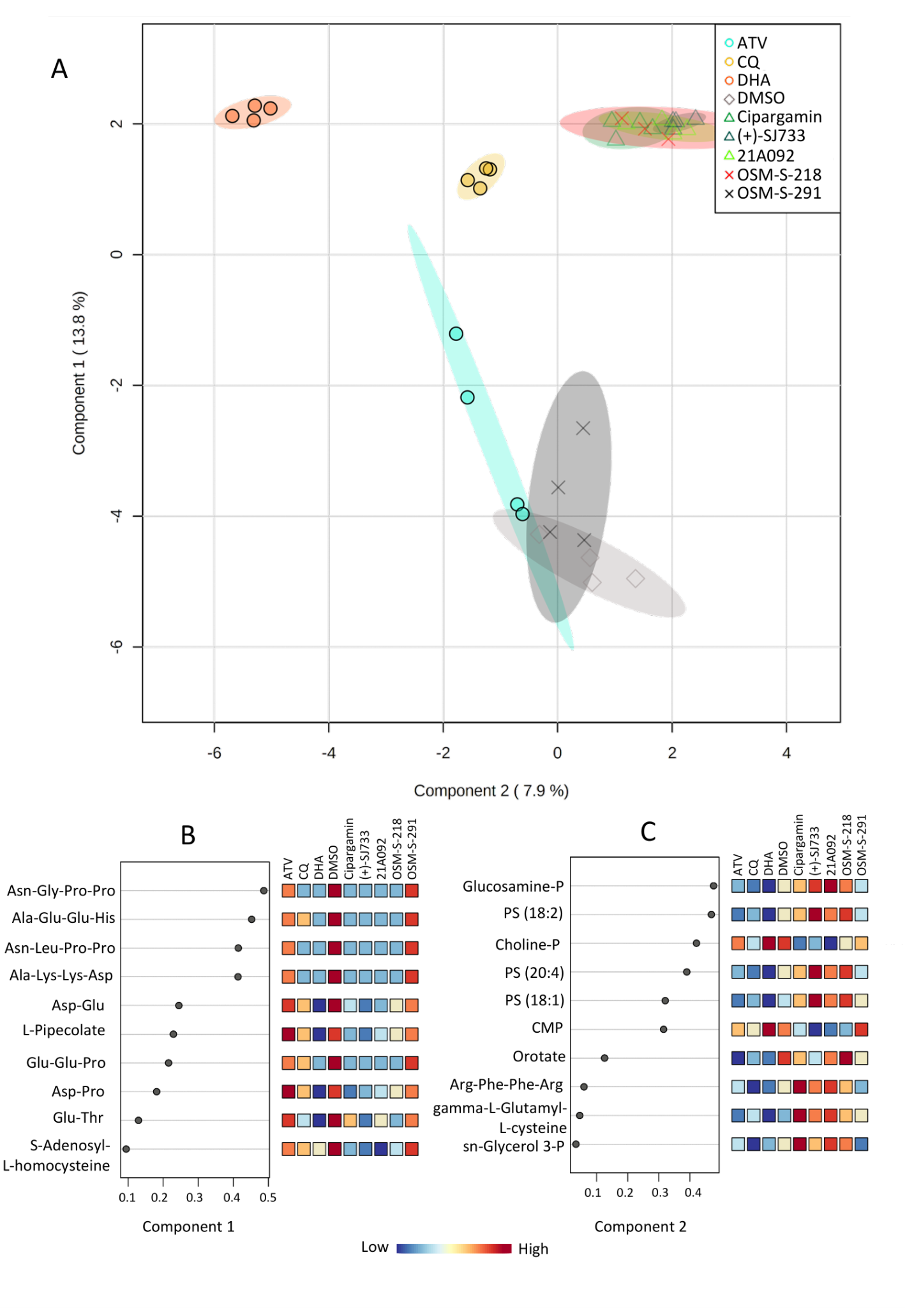

**Figure 9.** (A) Multivariate sparse-PLSDA analysis of levels of all putatively identified metabolites from P. falciparum-infected red blood cell pellets treated with OSM-S-218, OSM-S-291, dihydroartemisinin (DHA), chloroquine (CQ), atovaquone (ATV), *Pf*ATP4 inhibitors (Cipargamin, 21A092 and (+)-SJ733) and vehicle control (DMSO). (B/C) Sparse-PLSDA loadings of metabolite features responsible for the distribution of sample groups across components 1 (B) and 2 (C) in panel A and their mean relative abundance. Abbreviations: PS: phosphatidylserine, CMP: cytidine monophosphate, AMP: adenosine monophosphate.

Finally, the potential binding mode of Series 4 compounds to *Pf*ATP4 was investigated. *Pf*ATP4 has resisted attempts to generate a crystal structure, hindering attempts at rational drug design and indeed rationalisation of the varied chemotypes sharing the *Pf*ATP4-inhibition phenotype. **MMV670652**, the most potent compound in the series, was docked to a homology model of PfATP4 built from the crystal structure of the rabbit SERCA calcium pump ATPase 1 (PDB 2DQS) using Yasara and the Yasara2 knowledge-based force field. [10.1002/prot.22570] **MMV670652** was docked against the entire surface of *Pf*ATP4 using Smina. [10.1021/ci300604z] The highest scored binding site matches the modeled binding site of known *Pf*ATP4 inhibitor **SJ733**. [10.1073/pnas.1414221111] The site also corresponds to the binding site of phosphatidylethanolamine in the crystal structure of rabbit SERCA ATPase 1. The docked binding mode demonstrates the shape preference of the Series 4 compounds. The pocket has mixed hydrophobic/hydrophilic nature that provides favorable hydrogen bonds with the nitrogen-rich **MMV670652** (**Figure 10**). The pose supports many observed SAR trends, such as intolerance for extension at the triazolopyrazine 8-position due to clashing with *Pf*ATP L347, favorability of a polar tail at the northeast pendant phenyl due to hydrogen bonding with N207, and favorability of an extended hydrophobic northwest pendant phenyl ring. These binding poses were additionally used as the basis of a competition to develop predictive models for active compounds. A range of approaches were taken, leading to the design of novel chemical matter with activity in the blood stage potency assay; [10.26434/chemrxiv.13194755.v1] improving predictive and generative models is currently one of the open threads of the present project towards further lead optimization.

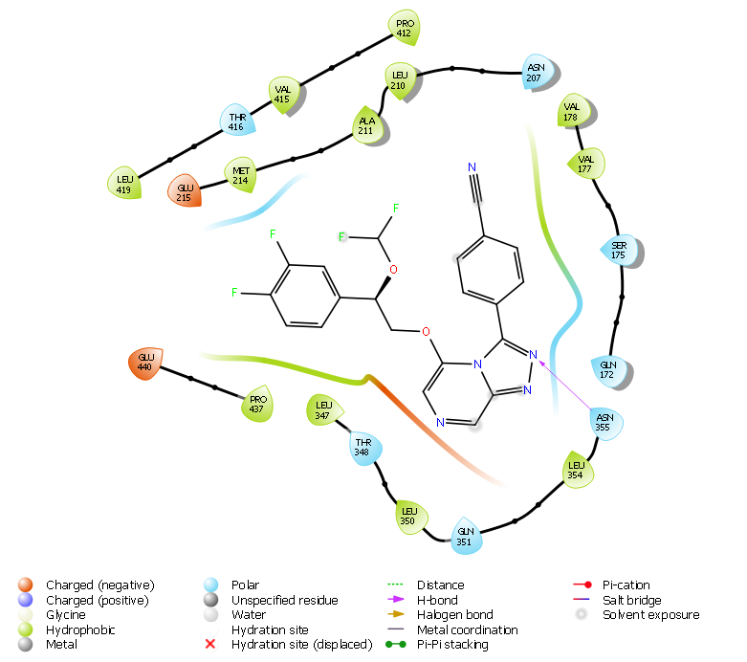

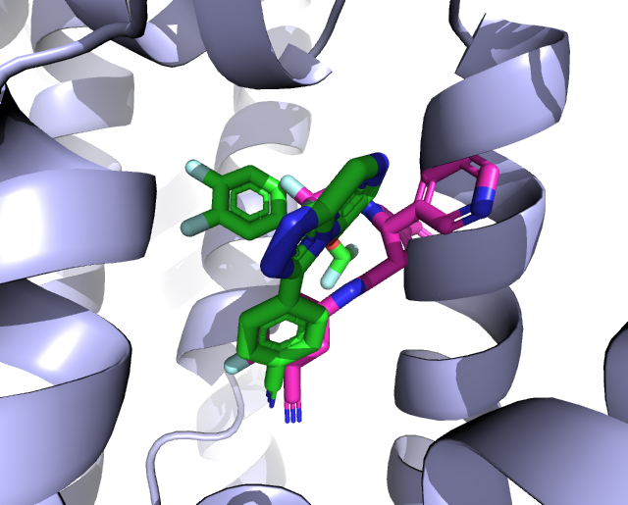

**Figure 10.** A) Docked binding mode of **MMV670652** (green) superimposed with the previously published docked pose of SJ733 (maroon) [10.1073/pnas.1414221111] in a homology model of *Pf*ATP4, and B) binding pocket interactions between the homology model and **MMV670652**.

## Activity vs Other Life Cycle Stages and Strains

Although the bloodstream stage of *Plasmodium* infection is responsible for symptomatic malaria, liver stage infection is an attractive target for the development of a prophylactic agent. [10.1038/nrmicro1529] Liver stage potency [was evaluated](http://malaria.ourexperiment.org/triazolopyrazine_se/8912) for two compounds (**MMV669844** and **MMV670944**), which revealed low levels of activity despite high blood stage potency (**Fig. 11**). The former compound was originally evaluated with an unknown enantiomeric composition; a subsequently prepared racemate was resolved, revealing differing blood stage potencies for the enantiomers, so it is possible that the liver stage activity arises also from one of the enantiomers but due to the low activity observed this was not pursued further. The low activity clearly distinguishes Series 4 from a structurally similar imidazopyrazine series discovered by Novartis that possesses activity against all liver stages in several *Plasmodium* species. [[doi.org/10.1038/nature12782](https://doi.org/10.1038/nature12782)] The two series are thought to possess distinct mechanisms of action (*Pf*ATP4 vs. PI4K).

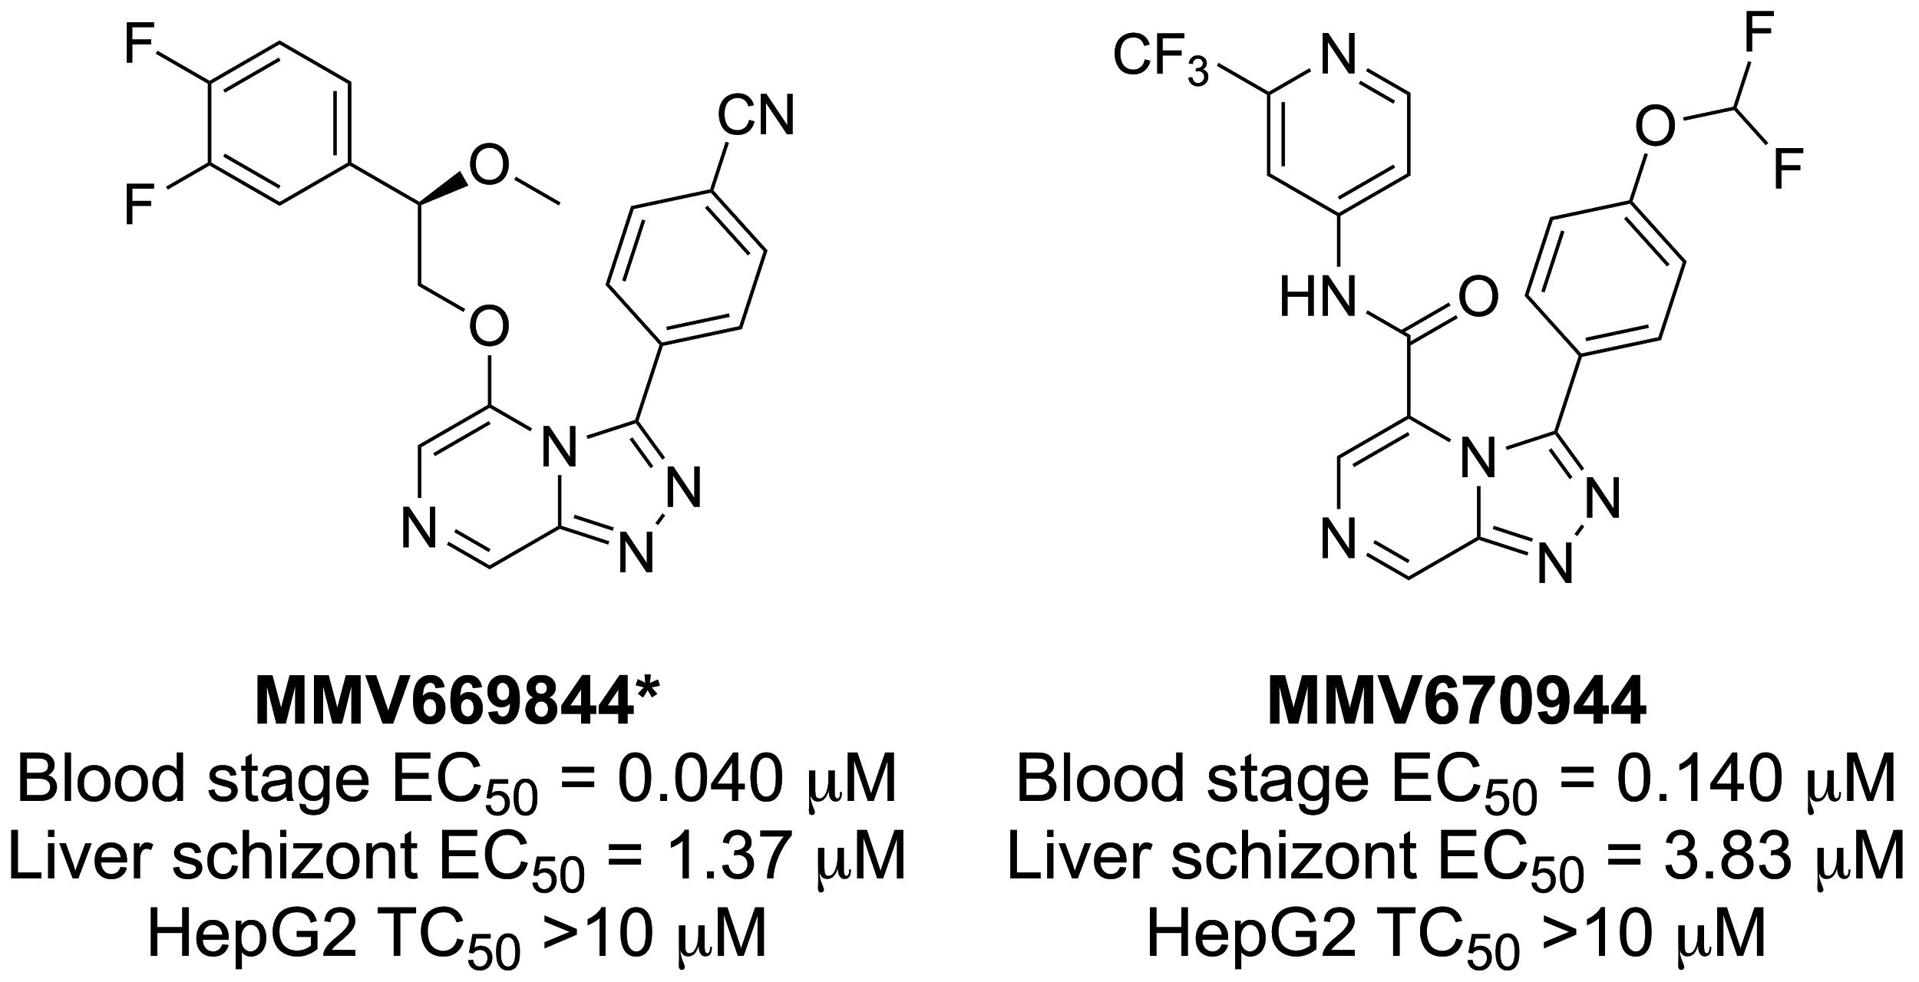

**Figure 11**. Results of liver stage screening. *Compound **MMV669844** is the inherited enantioenriched variant of the racemic compound **MMV897709**.

The gametocyte life cycle stage of *Plasmodium* is responsible for mediating transmission from an infected human host back to the mosquito vector. [10.1128/CMR.00051-10] Compounds that are active against gametocytes in addition to asexual life cycle stages are desirable as treatments and transmission-blocking agents. A selection of Series 4 compounds was assessed for anti-gametocyte activity. Though gametocidal activity (suspected to be via the triggering of premature exflagellation) has been seen for some (<http://dx.doi.org/10.1016/j.ijpddr.2015.07.001> and 10.1038/ncomms6521) but not all [[10.1371/journal.ppat.1005763](https://doi.org/10.1371/journal.ppat.1005763)] compounds thought to inhibit PfATP4, data for Series 4 was obtained showing that asexual-active active compounds are only weakly active or have no activity inhibitory activity against male gamete formation (**Table SX Delves**).

A representative compound (**MMV669844**) was found to exhibit unchanged potency (i.e., no cross resistance) against several drug-resistant parasite lines (Dd2, NF54, K1, 7G8, TM90C2B, Cam3.I) (**Table SX**).

## Evaluation against other Pathogens

Select Series 4 compounds were screened by the Community for Open Antimicrobial Drug Discovery (CO-ADD) against the ESKAPE pathogens *E. coli*, *S. aureus* (MRSA), *K. pneumoniae*, *A. baumannii*, and *P. aeruginosa*, and the fungi *C. neoformans* and C*. albicans*. [doi.org/10.1586/eri.13.12.] As is perhaps expected for compounds with a suspected mechanism of action involving PfATP4, no compounds screened showed >40% growth inhibition in a single-concentration assay (32 μg/mL) against the ESKAPE pathogens (**Table SX CO-ADD**).

# Conclusions

# 

We have described the lead optimization of a small molecule antiplasmodium series with the potential for the treatment of blood stage malaria infection. Besides the demonstrated *in vivo* efficacy in a mouse model of infection, the series of compounds also show particularly favourable properties that match the MMV progression criteria of potency, solubility and metabolic clearance. The central aim for future work is to uncover a way to combine these properties into a single molecular entity. The likely mechanism of action of the triazolopyrazine series, inhibition of *Pf*ATP4, is a highly promising antimalarial drug target, and, while cipargamin and SJ733 are being clinically evaluated, no other molecular series with this target as its MoA is yet approved for use in patients.

The project remains open to anyone to pursue, with several lines of enquiry being of particular note:

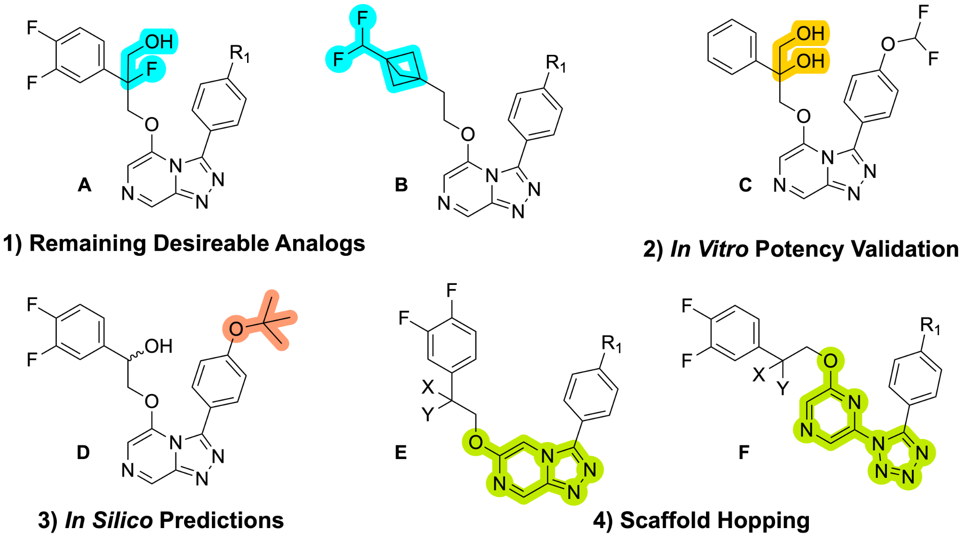

**Figure 12**. Future project directions including the synthesis of new analogues and the *in vitro* validation of the most promising compound. R1 = Cl, CN, or OCHF2. X and Y represent variable substitution on the benzylic position.

1. **Remaining Desirable Analogs**. As mentioned previously in the sections on SAR, an hydroxyl methyl substitution (**MMV670947** and **MMV693155**) on the benzylic position contributed to both potency and solubility, but that additional hydroxylation (**MMV1581298** and **MMV1581295**) resulted in reduced potency. It was also demonstrated in the *in vitr*o studies that leaving the benzylic position unblocked resulted in rapid oxidation to a less active metabolite. As a possible solution to this conundrum, the SAR profile did show that benzylic fluorination (**MMV672936** and **MMV672727**) was acceptable and produced active compounds. A natural extension to this logic presupposes that combining the both fluorine and hydroxylmethyl substitution at the benzylic position (**Compound A** in **Figure 12**) would yield an analog that is both potent and possesses increased metabolic stability. Further refinements to analogs with the optimized benzylic substitution could be made through adjustments to the phenyl substitutions on either the Northeast or Northwest portions of **Compound A**. In a separate investigation into the bioisosteric replacement of the Northwest phenyl group, it was found that a bicyclo[1.1.1]pentane (BCP) was an effective replacement for the northwest phenyl ring, with the molecule displaying an exceptional metabolic clearance profile but lacking in potency [DOI: 10.1021/acs.jmedchem.0c00746]. The low potency was most likely the result of poor spacing between BCP and core, since the corresponding benzyl-substituted compounds are similarly low in potency. A test of this hypothesis would be the one carbon elongated analog **Compound B** (**Figure 12**). The synthesis of the BCP-hydroxyethyl intermediate necessary to complete **Compound B** is non-trivial however, and has precluded its synthesis thus far without a more focused effort. Beyond the compounds mentioned here, other desirable targets have been curated and listed in within the online infrastructure of the Open Source Malaria project (https://github.com/OpenSourceMalaria/Series4/wiki/Desirable-Compounds-Not-Yet-Synthesised).
2. **Validation of the Activity of the dihydroxy MMV1580315 / MMV1581295**. This compound (**Compound C** in **Figure 12**), isolated from biofunctionalization experiments and subjected to lab resynthesis, has provided inconsistent potency data despite good solubility and other parameters. If potency can be clarified, and until newer analogs (such as those described in the previous Desireable Compounds section), this compound should next be assessed for *in vivo* PK to clarify and provide further guidance on the impact of modifying the benzylic position.
3. ***In silico* Predictions of Actives**. Success in recent predictive models should be pursued, particularly since such predictions are generative (i.e. able to suggest new chemical matter) and can be run with multiparameter optimization (e.g. solubility); during the writing of this manuscript new molecules were proposed *pro bono* by a company based on a newly-derived predictive model, for which OSM is now seeking synthetic chemists.
4. **Scaffold Hopping.** Compound **MMV670945** (see **Figure 2**), which transposed the ethoxy linker from the 5- to the 6-position of the triazolopyrazine core, showed excellent activity. While the 6-substituted triazolopyrazines were intriguing, due to the synthetic challenges surrounding this core, it was decided to first pursue the more tractable 5-substituted analogs first. It may now be time however, to take another look at the unexplored 6-substituted series (**Compound E** in **Figure 12**) and develop a focused library based on the SAR already developed in the 5-substituted series. Alternatively, while attempts were made to explore modifications of the triazolopyrazine core of the Series 4 scaffold through focused additions and deletions of heteroaromatic nitrogens (see **Figure 2**), a systematic effort to break away from the fused system was not attempted. The wealth of SAR knowledge that has been developed for the northwest, northeast, and linker portions of the Series 4 scaffold may therefore be able to be directly applied to a scaffold replacement such as **Compound F** (**Figure 12**). Work is currently ongoing to begin to explore this avenue of investigation.

The trajectory of the project described in this paper has followed a compelling and interesting path. It was initiated with a significant boost by a private sector pharmaceutical company before being transitioned to a Public Private Partnership entity, in collaboration with a contract research organisation, before ultimately reaching apogee in the public domain. This latter public, open source stage enabled wider input and participation, and as a result, the project was further advanced by approximately 200 people that included cohorts of undergraduate students, graduate students, unaffiliated volunteers, professors and private sector researchers. The laboratory work took place globally across multiple locations and was coordinated online through publicly available open means of communication. It was learned that active coordination and management of the open source project was essential for continued progress to be made and required several key points of contact to be maintained throughout. Another lesson was that despite switching to a highly distributed non-traditional model, basic drug discovery research remains expensive and the costs for normal lab operations, associated salaries, maintenance of screening platforms and instrument time remain. In contrast however, some efficiencies were realized using the open approach through significant project contributions given in-kind (e.g., advice/experiments from senior scientists), the ease of establishing collaborations, the solicitation of novel or fresh ideas and perspectives, and in the avoidance of accidental duplication of effort. Intellectual property arrangements were also simplified and streamlined due to the fact that the IP is non-proprietary and universally available, meaning no contribution will disproportionately benefit a single contributing party. While no molecule has yet progressed from a fully open project into the clinic, the progress made has served as a proof-of-concept that the strategy is sound and that through continued development and investment that there is a realistic chance of an ultimate benefit to underserved patient populations. Further refinement of the open model is still possible with multiple unconventional options that include sponsorship by collaborations between pharma and PDPs [doi:10.1186/1475-2875-10-143] or private sector development driven by protections afforded by existing regulatory data exclusivity arrangements. [[10.12688/wellcomeopenres.14947.1](https://doi.org/10.12688/wellcomeopenres.14947.1) & https://www.m4idpharma.com] Given the transparency of all the associated data, the openness of the approach may speed translation by virtue of the confidence investors have in the quality of the associated assets.

# Acknowledgements

We thank the Medicines for Malaria Venture (MMV) and the Australian Research Council for funding. Reference *Pf*ATP4 inhibitors were provided by MMV. [Add funding sources]. HLN was supported by NSF MCB CAREER Award 1350555. We thank Ursula Lehmann, Christoph Fischli and Sergio Wittlin (Swiss TPH, Basel, Switzerland) for help with the SCID mouse data for MMV669844. We gratefully acknowledge important early inputs into the project from Mike Palmer and James Mills (Pfizer). We gratefully acknowledge use of the open source electronic laboratory notebook Labtrove, created by the University of Southampton (Jeremy Frey) and support from that team in data hosting. We thank the team at the Community for Open Antimicrobial Drug Discovery for their assessment of a representative set of compounds. We thank the team at TCG Life Sciences, India, for their synthesis of the compounds inherited at the start of this project, and their provision of the relevant spectroscopic data (in particular Saumitra Sengupta, Abhijit Kundu and Anirban Kar)

# Author Contributions

**To be added.**

# 

# 

# **References**

# References currently in manuscript body at insertion points in blue brackets [].

Elizabeth A. Ashley, M.B., B.S., Ph.D., Mehul Dhorda, Ph.D., Rick M. Fairhurst, M.D., Ph.D., Chanaki Amaratunga, Ph.D., Parath Lim, M.D., Ph.D., Seila Suon, M.D., Sokunthea Sreng, Jennifer M. Anderson, Ph.D., Sivanna Mao, M.D., Baramey Sam, M.D., Chantha Sopha, M.D., Char Meng Chuor, M.D., M.P.H., Chea Nguon, M.D., Siv Sovannaroth, M.Sc., Sasithon Pukrittayakamee, M.B., D.Phil., Podjanee Jittamala, M.D., Kesinee Chotivanich, Ph.D., Kitipumi Chutasmit, M.D., Chaiyaporn Suchatsoonthorn, M.D., Ratchadaporn Runcharoen, M.D., Tran Tinh Hien, M.D., Ph.D., Nguyen Thanh Thuy-Nhien, Ph.D., Ngo Viet Thanh, M.D., Nguyen Hoan Phu, M.D., Ph.D., Ye Htut, M.B., B.S., M.Sc., Kay-Thwe Han, M.B., B.S., M.Med.Sc., Kyin Hla Aye, B.Sc., Olugbenga A. Mokuolu, M.B., B.S., F.W.A.C.P., Rasaq R. Olaosebikan, M.B., B.S., M.P.H., Olaleke O. Folaranmi, M.B., B.S., Mayfong Mayxay, M.D., Ph.D., Maniphone Khanthavong, M.D., Bouasy Hongvanthong, M.D., Paul N. Newton, M.R.C.P., Marie A. Onyamboko, M.D., M.P.H., Caterina I. Fanello, Ph.D., Antoinette K. Tshefu, M.D., Ph.D., Neelima Mishra, Ph.D., Neena Valecha, M.D., Aung Pyae Phyo, M.D., Francois Nosten, M.D., Ph.D., Poravuth Yi, M.D., Rupam Tripura, M.B., B.S., Steffen Borrmann, M.D., Mahfudh Bashraheil, Judy Peshu, M. Abul Faiz, M.B., B.S., Ph.D., Aniruddha Ghose, F.C.P.S., M. Amir Hossain, F.C.P.S., Rasheda Samad, F.C.P.S., M. Ridwanur Rahman, F.C.P.S., M. Mahtabuddin Hasan, F.C.P.S., Akhterul Islam, M.B., B.S., Olivo Miotto, Ph.D., Roberto Amato, Ph.D., Bronwyn MacInnis, Ph.D., Jim Stalker, M.A., Dominic P. Kwiatkowski, F.R.C.P., Zbynek Bozdech, Ph.D., Atthanee Jeeyapant, M.Sc., Phaik Yeong Cheah, Ph.D., Tharisara Sakulthaew, M.Sc., Jeremy Chalk, Ph.D., Benjamas Intharabut, B.Sc., Kamolrat Silamut, Ph.D., Sue J. Lee, Ph.D., Benchawan Vihokhern, B.Sc., Chanon Kunasol, M.Sc., Mallika Imwong, Ph.D., Joel Tarning, Ph.D., Walter J. Taylor, F.R.C.P., Shunmay Yeung, M.B., B.S., Ph.D., Charles J. Woodrow, M.D., Ph.D., Jennifer A. Flegg, Ph.D., Debashish Das, M.B., B.S., M.P.H., Jeffery Smith, B.A., Meera Venkatesan, Ph.D., Christopher V. Plowe, M.D., M.P.H., Kasia Stepniewska, Ph.D., Philippe J. Guerin, M.D., Ph.D., Arjen M. Dondorp, M.D., Ph.D., Nicholas P. Day, D.M., and Nicholas J. White. “Spread of Artemisinin Resistance in Plasmodium falciparum Malaria.” *New England Journal of Medicine* **2014**, *371*, 411-423. DOI: 10.1056/NEJMoa1314981

Yevgeniya Antonova-Koch, Stephan Meister, Matthew Abraham, Madeline R. Luth, Sabine Ottilie, Amanda K. Lukens, Tomoyo Sakata-Kato, Manu Vanaerschot, Edward Owen, Juan Carlos Jado, Steven P. Maher, Jaeson Calla, David Plouffe, Yang Zhong, Kaisheng Chen, Victor Chaumeau, Amy J. Conway, Case W. McNamara, Maureen Ibanez, Kerstin Gagaring, Fernando Neria Serrano, Korina Eribez, Cullin McLean Taggard, Andrea L. Cheung, Christie Lincoln, Biniam Ambachew, Melanie Rouillier, Dionicio Siegel, François Nosten, Dennis E. Kyle, Francisco-Javier Gamo, Yingyao Zhou, Manuel Llinás, David A. Fidock, Dyann F. Wirth, Jeremy Burrows, Brice Campo, Elizabeth A. Winzeler. “Open-source discovery of chemical leads for next-generation chemoprotective antimalarials.” *Science* **2018**, Vol. 362, Issue 6419. DOI: 10.1126/science.aat9446

Teun Bousema and Chris Drakeley. “Epidemiology and Infectivity of Plasmodium falciparum and Plasmodium vivax Gametocytes in Relation to Malaria Control and Elimination.” *Clinical Microbiology Reviews* **2011**, *24(2)*, 377-410. DOI: 10.1128/CMR.00051-10

M. H. Bridgland-Taylor, A. C. Hargreaves, A. Easter , A. Orme, D. C. Henthorn, M. Ding, A. M. Davis. B. G. Small, C. G. Heapy, N. Abi-Gerges, F. Persson, I. Jacobson, M. Sullivan, N. Albertson, T. G. Hammond, E. Sullivan, J.-P. Valentin, C. E. Pollard. “Optimisation and validation of a medium-throughput electrophysiology-based hERG assay using IonWorks™ HT.” *Journal of Pharmacological and Toxicological Methods* **2006**, *54(2)*, 189-199. DOI: 10.1016/j.vascn.2006.02.003

Monika Chugh, Christian Scheurer, Sibylle Sax, Elizabeth Bilsland, Donelly A. van Schalkwyk, Kathryn J. Wicht, Natalie Hofmann, Anil Sharma, Sridevi Bashyam, Shivendra Singh, Stephen G. Oliver, Timothy J. Egan, Pawan Malhotra, Colin J. Sutherland, Hans-Peter Beck, Sergio Wittlin, Thomas Spangenberg, and Xavier C. Ding. “Identification and Deconvolution of Cross-Resistance Signals from Antimalarial Compounds Using Multidrug-Resistant Plasmodium falciparum Strains.” *Antimicrobial Agents and Chemotherapy* **2015**, *59(2)*, 1101-1118. DOI: 10.1128/AAC.03265-14

Darren J. Creek, Hwa H. Chua, Simon A. Cobbold, Brunda Nijagal, James I. MacRae, Benjamin K. Dickerman, Paul R. Gilson, Stuart A. Ralph, Malcolm J. McConville. “Metabolomics-Based Screening of the Malaria Box Reveals both Novel and Established Mechanisms of Action.” *Antimicrob Agents Chemother.* **2016**, *60(11)*, 6650-6663. DOI: 10.1128/AAC.01226-16

Michael J. Delves, Ursula Straschil, Andrea Ruecker, Celia Miguel-Blanco, Sara Marques, Alexandre C. Dufour, Jake Baum and Robert E Sinden. “Routine *in vitro* culture of *P. falciparum* gametocytes to evaluate novel transmission-blocking interventions.” *Nature Protocols* **2016**, *11*, 1668–1680. DOI: 10.1038/nprot.2016.096

Adelaide S M Dennis, James E O Rosling, Adele M Lehane, and Kiaran Kirk. “Diverse antimalarials from whole-cell phenotypic screens disrupt malaria parasite ion and volume homeostasis.” *Sci. Rep.* **2018,** Jun 11; *8(1)*:*8795*. DOI: 10.1038/s41598-018-26819-1

Gilson P R, Kumarasingha R, Thompson J, Zhang X, Penington J S, Kalhor R, Bullen H E, Lehane A M, Dans M G, Koning-Ward T F d, Holien J K, Costa T P S d, Hulett M D, Buskes M J, Crabb B S, Kirk K, Papenfuss A T, Cowman A F, and Abbott B M. “A 4-cyano-3-methylisoquinoline inhibitor of *Plasmodium falciparum* growth targets the sodium efflux pump PfATP4.” *Sci Rep.* **2019**; *9: 10292*. DOI: 10.1038/s41598-019-46500-5

Arjen M. Dondorp, Frank M. Smithuis, Charley Woodrow, Lorenz von Seidlein. “How to Contain Artemisinin- and Multidrug-Resistant Falciparum.” *Malaria* **2017**, *33(5)*, 353-363. DOI: 10.1016/j.pt.2017.01.004

María Belén Jiménez-Díaz, Daniel Ebert, Yandira Salinas, Anupam Pradhan, Adele M. Lehane, Marie-Eve Myrand-Lapierre, Kathleen G. O’Loughlin, David M. Shackleford, Mariana Justino de Almeida, Angela K. Carrillo, Julie A. Clark, Adelaide S. M. Dennis, Jonathon Diep, Xiaoyan Deng, Sandra Duffy, Aaron N. Endsley, Greg Fedewa, W. Armand Guiguemde, María G. Gómez, Gloria Holbrook, Jeremy Horst, Charles C. Kim, Jian Liu, Marcus C. S. Lee, Amy Matheny, María Santos Martínez, Gregory Miller, Ane Rodríguez-Alejandre, Laura Sanz, Martina Sigal, Natalie J. Spillman, Philip D. Stein, Zheng Wang, Fangyi Zhu, David Waterson, Spencer Knapp, Anang Shelat, Vicky M. Avery, David A. Fidock, Francisco-Javier Gamo, Susan A. Charman, Jon C. Mirsalis, Hongshen Ma, Santiago Ferrer, Kiaran Kirk, Iñigo Angulo-Barturen, Dennis E. Kyle, Joseph L. DeRisi, David M. Floyd, and R. Kiplin Guy. “(+)-SJ733, a clinical candidate for malaria that acts through ATP4 to induce rapid host-mediated clearance of Plasmodium.” PNAS December 16, **2014** *111(50)*, E5455-E5462. DOI: 10.1073/pnas.1414221111

David Ryan Koes, Matthew P. Baumgartner, and Carlos J. Camacho. “Lessons Learned in Empirical Scoring with smina from the CSAR 2011 Benchmarking Exercise.” *J. Chem. Inf. Model.* **2013**, *53(8)*, 1893–1904. DOI: doi.org/10.1021/ci300604z

Marat Korsik, Edwin G. Tse, David G. Smith, William Lewis, Peter J. Rutledge*, and Matthew H. Todd. “tele-Substitution Reactions in the Synthesis of a Promising Class of 1,2,4-Triazolo[4,3*-a*]pyrazine-Based Antimalarials.” *J. Org. Chem.* **2020**, *85(21)*, 13438–13452. DOI: 10.1021/acs.joc.0c01045

Elmar Krieger, Keehyoung Joo, Jinwoo Lee, Jooyoung Lee, Srivatsan Raman, James Thompson, Mike Tyka, David Baker, and Kevin Karplus. “Improving physical realism, stereochemistry,and side-chain accuracy in homology modeling: Four approaches that performed well in CASP8.” *Proteins* **2009**. DOI: 10.1002/prot.22570

Kim-Anh Lê Cao, Simon Boitard and Philippe Besse. “Sparse PLS discriminant analysis: biologically relevant feature selection and graphical displays for multiclass problems.” *BMC Bioinformatics* **2011**, *12(253)*. DOI: 10.1186/1471-2105-12-253

Adele M. Lehane, Melanie C. Ridgway, Eileen Baker and Kiaran Kirk. “Diverse chemotypes disrupt ion homeostasis in the malaria parasite.” *Molecular Microbiology* **2014**, *94(2)*, 327–339. DOI: 10.1111/mmi.12765

Claire Le Manach, Tanya Paquet, Christel Brunschwig, Mathew Njoroge, Ze Han, DiegoGonzal̀ezCabrera, Sridevi Bashyam, Rajkumar Dhinakaran, Dale Taylor, Janette Reader, Mariette Botha, Alisje Churchyard, Sonja Lauterbach, Theresa L. Coetzer, Lyn-Marie Birkholtz, Stephan Meister, Elizabeth A. Winzeler, David Waterson, Michael J. Witty, Sergio Wittlin, María-Beleń Jimeńez-Díaz, María Santos Martínez, Santiago Ferrer, Iñigo Angulo-Barturen, Leslie J. Street, and Kelly Chibale. “A Novel Pyrazolopyridine with in Vivo Activity in *Plasmodium berghei-* and *Plasmodium falciparum*-Infected Mouse Models from Structure−Activity Relationship Studies around the Core of Recently Identified Antimalarial Imidazopyridazines.” *Journal of Medicinal Chemistry* **2015**, *58*, 8713-8722. DOI: 10.1021/acs.jmedchem.5b01605

Claire Le Manach, Diego Gonzal̀ez Cabrera, Frederic Douelle, Aloysius T. Nchinda, Yassir Younis, Dale Taylor, Lubbe Wiesner, Karen L. White, Eileen Ryan, Corinne March, Sandra Duffy, Vicky M. Avery, David Waterson, Michael J. Witty, Sergio Wittlin, Susan A. Charman, Leslie J. Street, and Kelly Chibale. “Medicinal Chemistry Optimization of Antiplasmodial Imidazopyridazine Hits from High Throughput Screening of a SoftFocus Kinase Library: Part 1.” *Journal of Medicinal Chemistry* **2014**, *57*, 2789-2798. DOI: 10.1021/jm500098s

Case W. McNamara, Marcus C. S. Lee, Chek Shik Lim, Siau Hoi Lim, Jason Roland, Advait Nagle, Oliver Simon, Bryan K. S. Yeung, Arnab K. Chatterjee, Susan L. McCormack, Micah J. Manary, Anne-Marie Zeeman, Koen J. Dechering, T. R. Santha Kumar, Philipp P. Henrich, Kerstin Gagaring, Maureen Ibanez, Nobutaka Kato, Kelli L. Kuhen, Christoph Fischli, Matthias Rottmann, David M. Plouffe, Badry Bursulaya, Stephan Meister, Lucia Rameh, Joerg Trappe, Dorothea Haasen, Martijn Timmerman, Robert W. Sauerwein, Rossarin Suwanarusk, Bruce Russell, Laurent Renia, Francois Nosten, David C. Tully, Clemens H. M. Kocken, Richard J. Glynne, Christophe Bodenreider, David A. Fidock, Thierry T. Diagana and Elizabeth A. Winzeler. “Targeting Plasmodium PI(4)K to eliminate malaria.” *Nature* **2013**, *504*, 248-253. DOI: <https://doi.org/10.1038/nature12782>

MMV Website - Our History. <https://www.mmv.org/about-us/what-we-do/our-history>. Accessed 14-DEC-2020

MMV Website - Press Release - Pfizer and MMV advancing international research efforts in the fight against malaria. <https://www.mmv.org/newsroom/press-releases/pfizer-and-mmv-advancing-international-research-efforts-fight-against>. Accessed 16-DEC-2020

MMV Website - Potential new class of antimalarials now open source. <https://www.mmv.org/newsroom/news/potential-new-class-antimalarials-now-open-source>. Accessed 16-DEC-2020

Openmolecules.org Website - DataWarrior: An Open-Source Program for Data Visualization and Analysis with Chemical Intelligence. <http://www.openmolecules.org/datawarrior/>. Accessed 18-DEC-2020

Jack N. Pendleton, Sean P. Gorman, Brendan F. Gilmore. “Clinical relevance of the ESKAPE pathogens.” Expert Review of Anti-infective Therapy **2013**, *11(3)*, 297-308. DOI: doi.org/10.1586/eri.13.12

Pfizer Website - Press Release - Pfizer and MMV advancing international research efforts in the fight against malaria. <https://www.pfizer.com/news/press-release/press-release-detail/pfizer_and_medicines_for_malaria_venture_advancing_international_research_efforts_in_the_fight_against_malaria>. Accessed 16-DEC-2020

Miguel Prudêncio, Ana Rodriguez and Maria M. Mota. “The silent path to thousands of merozoites: the Plasmodium liver stage.” *Nature Reviews Microbiology* **2006**, *4*, 849-856. DOI: 10.1038/nrmicro1529

James E. O. Rosling, Melanie C. Ridgway, Robert L. Summers, Kiaran Kirk, and Adele M. Lehane. “Biochemical characterization and chemical inhibition of PfATP4-associated Na+-ATPase activity in *Plasmodium falciparum* membranes. *J. Biol. Chem.* **2018**, *293(34)*, 13327–13337. DOI: 10.1074/jbc.RA118.003640

Natalie J. Spillman, Richard J. W. Allen, Case W. McNamara, Bryan K. S. Yeung, Elizabeth A. Winzeler, Thierry T. Diagana, and Kiaran Kirk. “Na+ Regulation in the Malaria Parasite *Plasmodium falciparum* Involves the Cation ATPase PfATP4 and Is a Target of the Spiroindolone Antimalarials.” *Cell Host & Microbe* **2013**, *13*, 227–237. DOI: 10.1016/j.chom.2012.12.006

Natalie Jane Spillman and Kiaran Kirk. “The malaria parasite cation ATPase PfATP4 and its role in the mechanism of action of a new arsenal of antimalarial drugs.” *International Journal for Parasitology: Drugs and Drug Resistance* **2015**, *5*, 149-162. DOI: 10.1016/j.ijpddr.2015.07.001

W Trager, J B Jensen. “Human malaria parasites in continuous culture.” *Science* **1976**, Vol. 193, Issue 4254, 673-675. DOI: 10.1126/science.781840

Tse, Edwin G., Marat Korsik, and Matthew H. Todd. 2019. “The past, present and future of anti-malarial medicines.” *Malaria Journal* **2019**, *18(93)*, 1-21. DOI: 10.1186/s12936-019-2724-z.

Edwin G. Tse, Sevan D. Houston, Craig M. Williams, G. Paul Savage, Louis M. Rendina, Irene Hallyburton, Mark Anderson, Raman Sharma, Gregory S. Walker, R. Scott Obach, and Matthew H. Todd. “Nonclassical Phenyl Bioisosteres as Effective Replacements in a Series of Novel Open-Source Antimalarials.” *J. Med. Chem.* **2020**, *63(20*), 11585–11601. DOI: 10.1021/acs.jmedchem.0c00746

Antonia F. Stepan, A.F., Walker, D.P., Bauman, J., Price, D.A., Baillie, T.A., Kalgutkar, A.S., Aleo, M.D., “Structural Alert/Reactive Metabolite Concept as Applied in Medicinal Chemistry to Mitigate the Risk of Idiosyncratic Drug Toxicity: A Perspective Based on the Critical Examination of Trends in the Top 200 Drugs Marketed in the United States”, Chem. Res. Toxicol. (2011) 24(9), pp. 1345-1410. <https://doi.org/10.1021/tx200168d>

Amit S. Kalgutkar, “Should the Incorporation of Structural Alerts be Restricted in Drug Design? An Analysis of Structure-Toxicity Trends with Aniline-Based Drugs”, Current Medicinal Chemistry (2015) 22, pp. 438-464. <https://doi.org/10.2174/0929867321666141112122118>

Taylor M. Sodano, Logan A. Combee, and Corey R. J. Stephenson, “Recent Advances and Outlook for the Isosteric Replacement of Anilines”, ACS Med. Chem. Lett. (2020) 11, pp. 1785-1788. <https://dx.doi.org/10.1021/acsmedchemlett.9b00687>

Akhil B. Vaidya, Joanne M. Morrisey, Zhongsheng Zhang, Sudipta Das, Thomas M. Daly, Thomas D. Otto, Natalie J. Spillman, Matthew Wyvratt, Peter Siegl, Jutta Marfurt, Grennady Wirjanata, Boni F. Sebayang, Ric N. Price, Arnab Chatterjee, Advait Nagle, Marcin Stasiak, Susan A. Charman, Iñigo Angulo-Barturen, Santiago Ferrer, María Belén Jiménez-Díaz, María Santos Martínez, Francisco Javier Gamo, Vicky M. Avery, Andrea Ruecker, Michael Delves, Kiaran Kirk, Matthew Berriman, Sandhya Kortagere, Jeremy Burrows, Erkang Fan and Lawrence W. Bergman. “Pyrazoleamide compounds are potent antimalarials that target Na+ homeostasis in intraerythrocytic Plasmodium falciparum.” Nat. Commun. **2014**, *5:5521*. DOI: 10.1038/ncomms6521

Gregory S. Walker, Jonathan N. Bauman, Tim F. Ryder, Evan B. Smith, Douglas K. Spracklin and R. Scott Obach. “Biosynthesis of Drug Metabolites and Quantitation Using NMR Spectroscopy for Use in Pharmacologic and Drug Metabolism Studies.” *Drug Metabolism and Disposition* **2014**, *42 (10)*, 1627-1639; DOI: 10.1124/dmd.114.059204

Alice E. Williamson, Paul M. Ylioja, Murray N. Robertson, Yevgeniya Antonova-Koch, Vicky Avery, Jonathan B. Baell, Harikrishna Batchu, Sanjay Batra, Jeremy N. Burrows, Soumya Bhattacharyya, Felix Calderon, Susan A. Charman, Julie Clark, Benigno Crespo, Matin Dean, Stefan L. Debbert, Michael Delves, Adelaide S. M. Dennis, Frederik Deroose, Sandra Duffy, Sabine Fletcher, Guri Giaever, Irene Hallyburton, Francisco-Javier Gamo, Marinella Gebbia, R. Kiplin Guy, Zoe Hungerford, Kiaran Kirk, Maria J. Lafuente-Monasterio, Anna Lee, Stephan Meister, Corey Nislow, John P. Overington, George Papadatos, Luc Patiny, James Pham, Stuart A. Ralph, Andrea Ruecker, Eileen Ryan, Christopher Southan, Kumkum Srivastava, Chris Swain, Matthew J. Tarnowski, Patrick Thomson, Peter Turner, Iain M. Wallace, Timothy N. C. Wells, Karen White, Laura White, Paul Willis, Elizabeth A. Winzeler, Sergio Wittlin, and Matthew H. Todd. “Open Source Drug Discovery: Highly Potent Antimalarial Compounds Derived from the Tres Cantos Arylpyrroles.” *ACS Cent. Sci.* **2016**, *2(10)*, 687-701. DOI: 10.1021/acscentsci.6b00086

World Health Organization. (2020, November 30). *World malaria report 2020: 20 years of global progress and challenges*. World Malaria Report 2020. Retrieved December 14, 2020, from <https://www.who.int/teams/global-malaria-programme/reports/world-malaria-report-2020> ISBN 978-92-4-001579-1

Jianguo Xia and David S. Wishart. “Using MetaboAnalyst 3.0 for Comprehensive Metabolomics Data Analysis.” *Current Protocols in Bioinformatics* **2016**, *55(1)*, 14.10.1-14.10.91: DOI: 10.1002/cpbi.11

Bin Zou, Advait Nagle, Arnab K. Chatterjee, Seh Yong Leong, Liying Jocelyn Tan, Wei Lin Sandra Sim, Pranab Mishra, Prasuna Guntapalli, David C. Tully, Suresh B. Lakshminarayana, Chek Shik Lim, Yong Cheng Tan, Siti Nurdiana Abas, Christophe Bodenreider, Kelli L. Kuhen, Kerstin Gagaring, Rachel Borboa, Jonathan Chang, Chun Li, Thomas Hollenbeck, Tove Tuntland, Anne-Marie Zeeman, Clemens H. M. Kocken, Case McNamara, Nobutaka Kato, Elizabeth A. Winzeler, Bryan K. S. Yeung, Thierry T. Diagana, Paul W. Smith, and Jason Roland. “Lead Optimization of Imidazopyrazines: A New Class of Antimalarial with Activity on Plasmodium Liver Stages.” *ACS Med. Chem. Lett.* **2014**, *5*, 947−950. DOI: 10.1021/ml500244m

François Bompart, Jean-René Kiechel2, Robert Sebbag and Bernard Pecoul. “Innovative public-private partnerships to maximize the delivery of anti-malarial medicines: lessons learned from the ASAQ Winthrop experience.” *Malaria Journal* **2011**, 10:143. DOI: 10.1186/1475-2875-10-143

a) Morgan MR, Roberts OG and Edwards AM. “Ideation and implementation of an open science drug discovery business model – M4K Pharma.” *Wellcome Open Res* 2018, 3:154 DOI: [10.12688/wellcomeopenres.14947.1](https://doi.org/10.12688/wellcomeopenres.14947.1); b) M4ID (Medicines for Infectious Disease) website. <https://www.m4idpharma.com>. Accessed 13-MAY-2021.

Igor Shamovsky, Lena Ripa, Frank Narjes, Britta Bonn, Stefan Schiesser, Ina Terstiege, and Christian Tyrchan. “Mechanism-Based Insights into Removing the Mutagenicity of Aromatic Amines by Small Structural Alterations.” *J. Med. Chem.* **2021**, ASAP. DOI: 10.1021/acs.jmedchem.1c00514